APPENDIX A

Habitat Descriptions of Survey Sites
Physical habitat characteristics at each of the study sites surveyed for FYLFs in the bypass and peaking reaches and their tributaries and in the comparison stream reaches and their tributaries are described in the following sections.

BYPASS AND PEAKING REACHES
Physical habitat characteristics of the sites surveyed for FYLFs in the bypass and peaking reaches are described in the following sections.

Middle Fork American River, RM 0.0 – 24.7 (Peaking Reach)
Seven sites were surveyed in the peaking reach. The sites included AMPH MF 6.4, AMPH MF 9.3, AMPH MF 11.0, AMPH MF 14.1, AMPH MF 19.1, AMPH MF 21.0, and AMPH MF 24.1. The general characteristics of the sites in the peaking reach are described below.

The Middle Fork American River between the confluence with the North Fork American River and Ralston Afterbay was generally a low gradient alluvial river with high amplitude meanders around large point bars. The upper section of the peaking reach was dominated by cobble-sized material, while gravel and sand-sized particles were most common in the lower section. The exception was a one 1.2-mile long bedrock-controlled reach (Ruck-a-Chucky rapids reach), where the valley narrows and bedrock and boulders were the dominant substrate. The AMPH MF 9.3 site is located within this reach. Sediment storage was substantially greater in the peaking reach compared to upstream of Ralston Afterbay and the other bypass streams. In addition to the large point bars, side bars and numerous mid-channel bars were also present (PCWA 2007). Riparian vegetation distribution was patchy, and comprised of willow and alder shrubs and trees. Riparian canopy cover along the stream margins was generally low, although in some locations, canopy cover was dense with riparian shrubs established along the low-flow channel margins. Shallow, cobble-dominated pool tailouts and runs that can be FYLF breeding habitat were common throughout the peaking reach. In addition, small high flow side channels, with potential habitat, were present in AMPH MF 6.4 and AMPH MF 14.1.

Flows in the peaking reach fluctuated considerably both between days and within a day. Daily flows can fluctuate between the minimum instream flow requirement (75 cfs) and the capacity of the Oxbow Powerhouse (1,080 cfs). During the breeding season (May 10 through June 5), average daily flows recorded at the top of the peaking reach fluctuated from approximately 280 cfs to 750 cfs (Gage No. 11433300). During the month of August, average daily flows ranged between 435 cfs and 650 cfs. Average daily water temperatures warmed with distance downstream during the breeding season and in August. Immediately downstream of Ralston Afterbay, the average daily water temperature was 58 ºF (ranging from 55 ºF to 62 ºF) during the breeding season. Just upstream of the North Fork American River confluence (RM 0.1), water temperatures ranged from 58 ºF to 73 ºF, with an average daily water temperature of 66 ºF. In August just downstream of Ralston Afterbay, the average daily water temperature was 60 ºF, ranging between 56 ºF and 65 ºF. At RM 0.1, August water temperatures ranged from 60 ºF to 71 ºF, with an average daily water temperature of 65 ºF. Non-native predators, Brown trout and crayfish, were observed throughout the reach.

AMPH MF 6.4 MIDDLE FORK AMERICAN RIVER
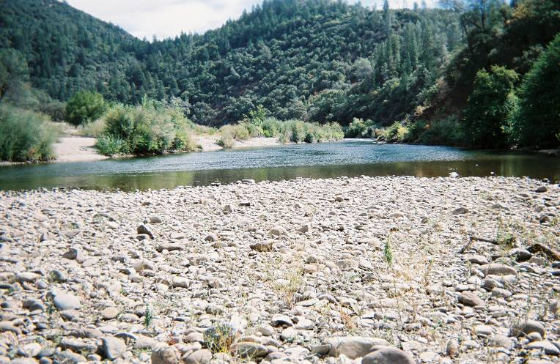 |  | 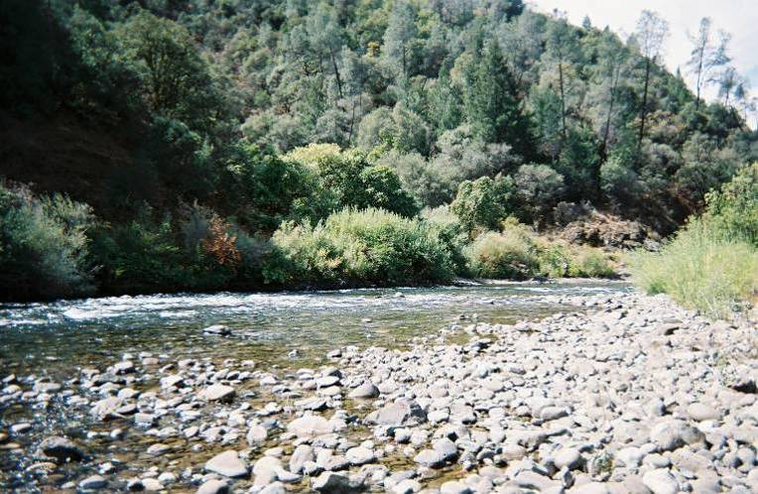
Representative breeding habitat at upstream end of cobble bar, looking upstream. | Representative habitat looking upstream across river at American Canyon Creek confluence.

AMPH MF 9.3 MIDDLE FORK AMERICAN RIVER
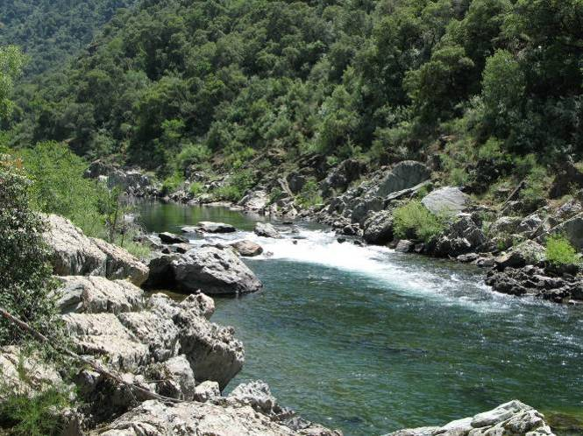 | 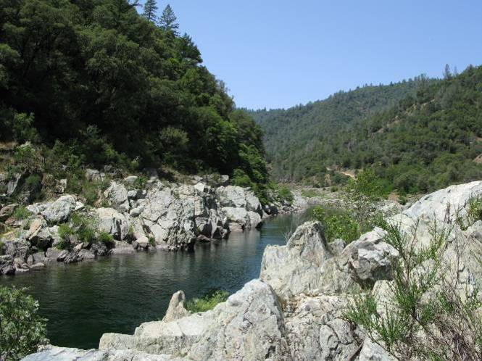
Representative habitat in the Middle Fork American River, looking upstream. |  | Potential breeding habitat along the shallow bedrock stream margin, looking upstream. Buca and Hyre tadpoles were observed in shallow pools.

AMPH MF 11.0 MIDDLE FORK AMERICAN RIVER
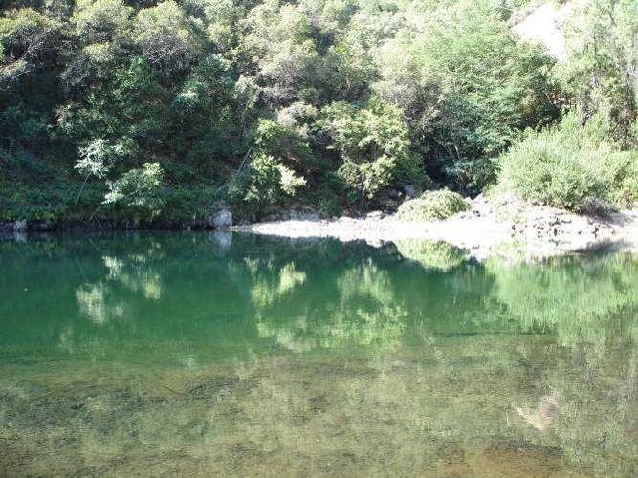 | 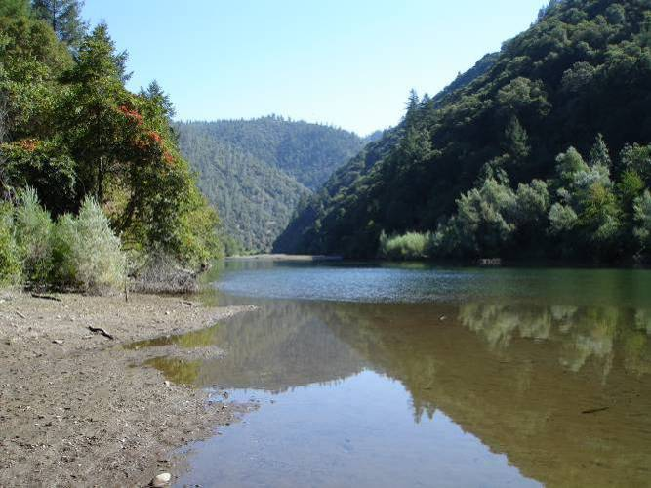
Pool habitat looking across to the Canyon Creek confluence. | Representative habitat looking upstream.

AMPH MF 14.1 MIDDLE FORK AMERICAN RIVER
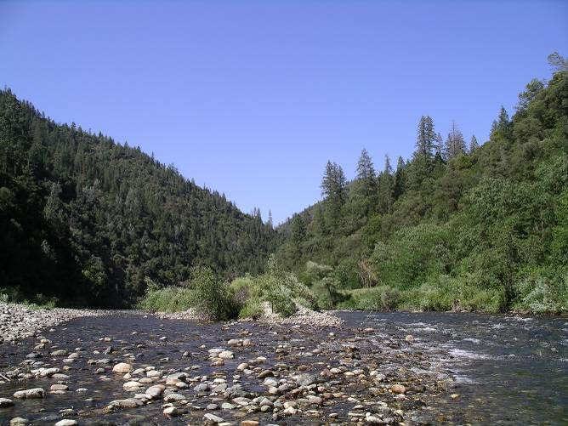 | 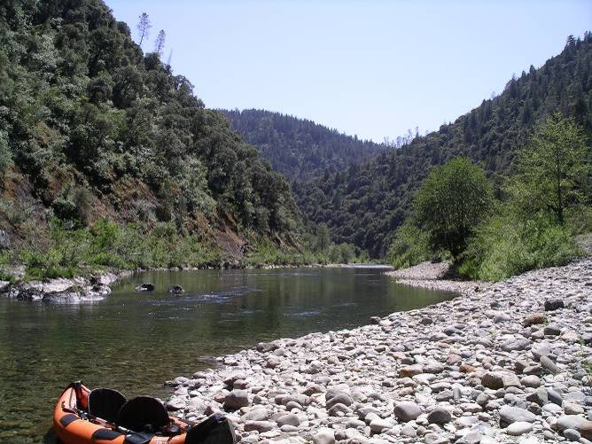
Representative habitat for the Middle Fork American River, looking downstream from the upstream end of survey reach. Potential breeding habitat was present along cobble bar margins. | Potential breeding habitat in side channel and upstream end of cobble bar, looking downstream.

AMPH MF 19.1 MIDDLE FORK AMERICAN RIVER - CACHE ROCK
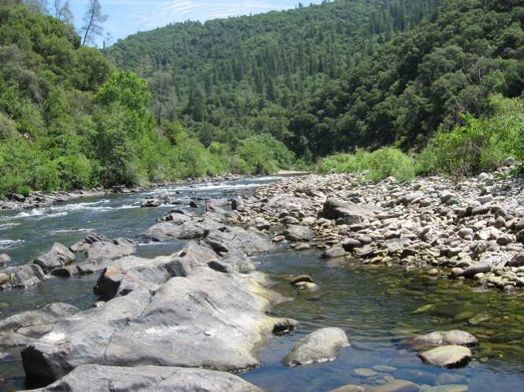 | 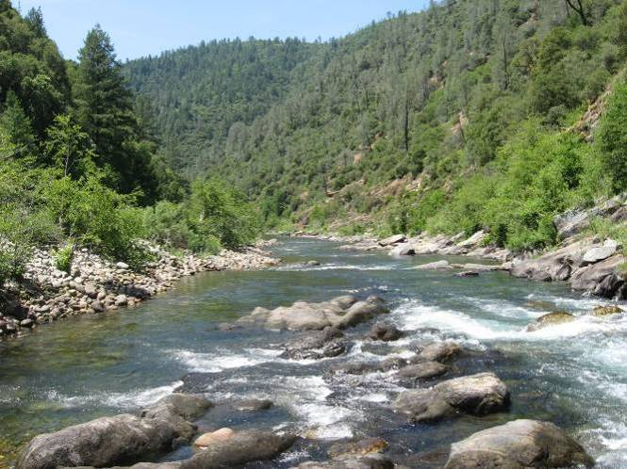
Representative habitat for Middle Fork American River, looking downstream. | Potential breeding habitat along cobble bar margin, looking downstream.

AMPH MF 21.0 MIDDLE FORK AMERICAN RIVER
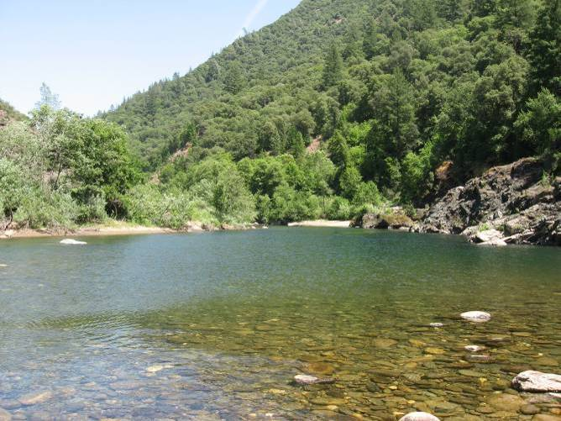 | 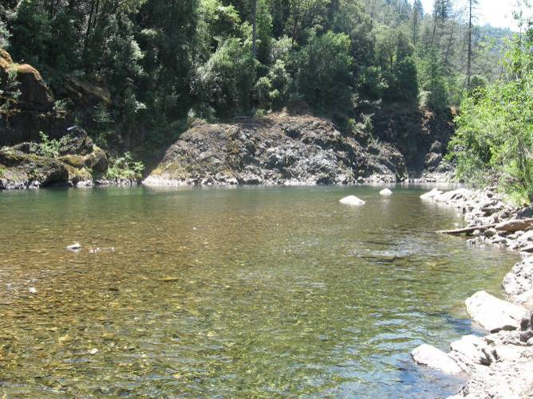
Representative habitat for the Middle Fork American River, looking upstream. | Potential breeding habitat along in the pool tail-out at upstream end of the cobble bar, looking upstream.

AMPH MF 24.1 MIDDLE FORK AMERICAN RIVER BELOW RALSTON AFTERBAY
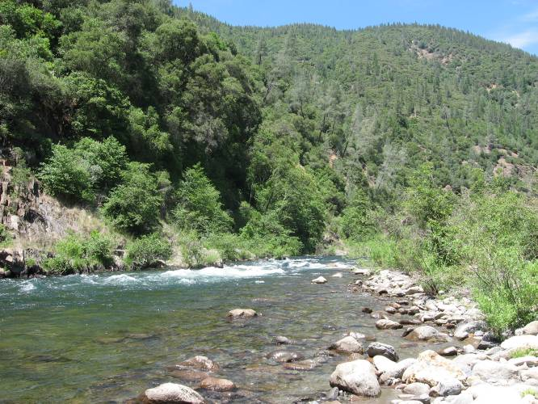 | 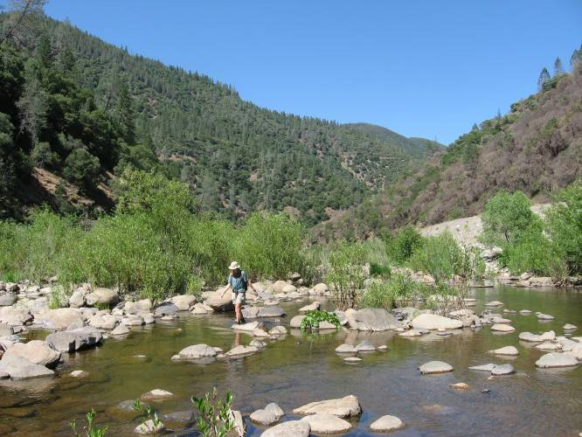
Representative habitat for the Middle Fork American River, looking upstream. | Potential breeding habitat along the margin of the cobble bar, looking upstream.

Surveyed Tributaries to the Middle Fork American River, RM 0.0 – 24.7
Seven unregulated tributaries to the Middle Fork American River were surveyed for FYLF. These included American Canyon, Todd Creek, Gas Canyon, Canyon Creek, Otter Creek, Volcano Creek, and the North Fork of the Middle Fork American River. Incidental site visits were completed at two sites on tributaries to the peaking reach, including Jesse Canyon (AMPH MF 17.0) and Pond Creek (AMPH MF 18.1). Physical habitat characteristics of these creeks are described below.

AMPH MF 6.4 American Canyon Creek
American Canyon Creek was a narrow, confined perennial stream. Sections of cobble runs alternated with steeper bedrock cascades and pools sections. Riparian vegetation was patchy along the water’s edge, and was dominated by small to medium-sized willow shrubs and alder trees. Bedrock and cobble were the dominant substrates. Suitable breeding locations were primarily available in low-gradient cobble substrate runs and shallow pool-tailouts, which occurred in about one-quarter of the site.

Flows were approximately 1 cfs during the fall surveys. Non-native aquatic predators were not observed.

AMPH MF 6.4 AMERICAN CANYON CREEK
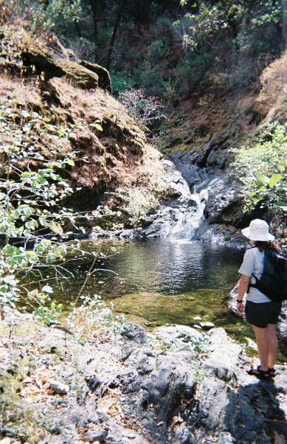 |  | 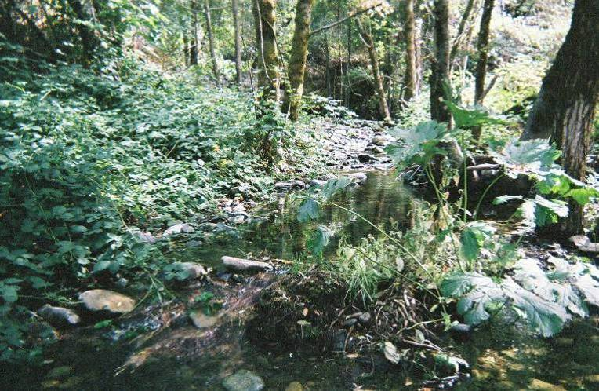
Representative step-pool habitat; looking upstream. | Representative riffle-run cobble boulder habitat, looking upstream.

AMPH MF 9.3 Todd Creek
Todd Creek was an ephemeral stream in 2007. The stream channel was approximately 3 meters wide, with an adjacent floodplain along both banks. Upstream of Drivers Flat Road, valley width decreased, and the channel was confined within steep canyon walls. Riparian vegetation downstream of Drivers Flat Road was dominated by small to medium-sized willow and alder trees and shrubs. Canopy coverage along the stream margins was generally less than 25%, with dense vegetation with up to 100% cover in some areas. Bedrock and boulder were the dominant channel substrates. Suitable breeding locations occurred in shallow, low velocity areas behind bedrock/boulders along the margins of a few small plunge pools.

Spring flows were less than 1 cfs. The creek was dry during the fall field surveys. Non-native aquatic predators were not observed.

AMPH MF 9.3 TODD CREEK
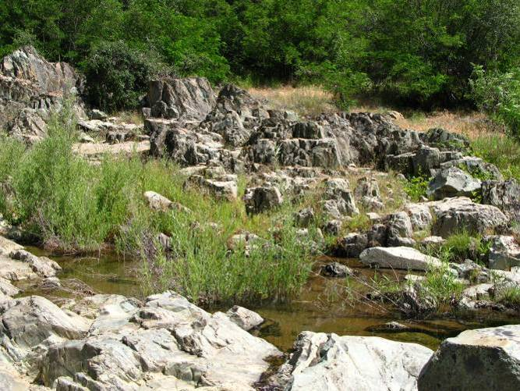 | 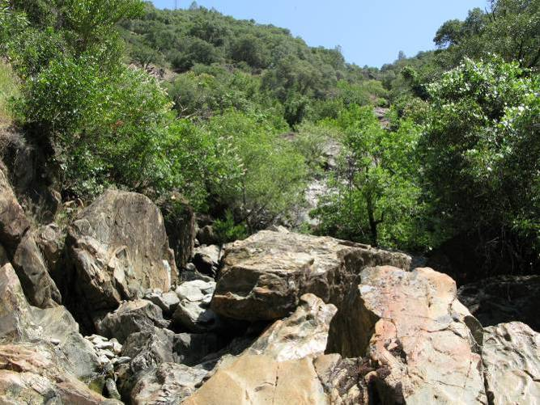
Eggmass was observed in the bedrock pool at the Middle Fork American River confluence. Pool dried up later in summer. No tadpoles were observed during August surveys. |  | Representative habitat for Todd Creek, looking upstream.

AMPH MF 9.3 Gas Canyon Creek
Gas Canyon Creek was a narrow (less than 10 meters wide), high-gradient intermittent stream with steep confined canyon walls and no floodplain. In the lower portion of the reach, small pools and cascades dominated, while upstream the gradient increased with larger cascades and pools. Canopy cover along the stream margins was variable within the reach, ranging from 0 to 100%. Willow and alder shrubs and trees were the primary shade providers. Bedrock and cobble were the dominant substrates. Suitable breeding habitat occurred in pool tail-outs and the edges of runs.

Flows were less than 5 cfs during the breeding season surveys. Water was not flowing during the August field survey, although pools remained. Crayfish were observed during surveys.

AMPH MF 9.3 GAS CANYON CREEK
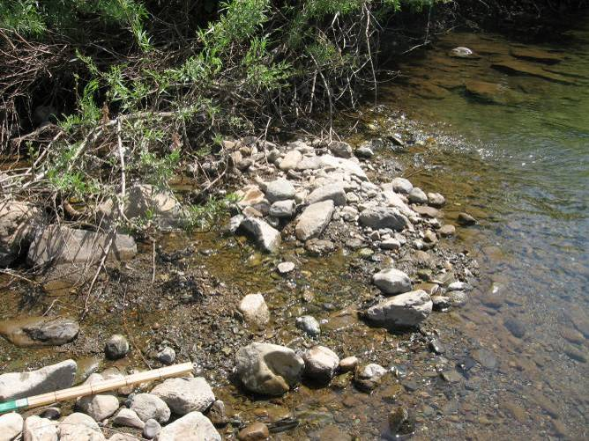 | 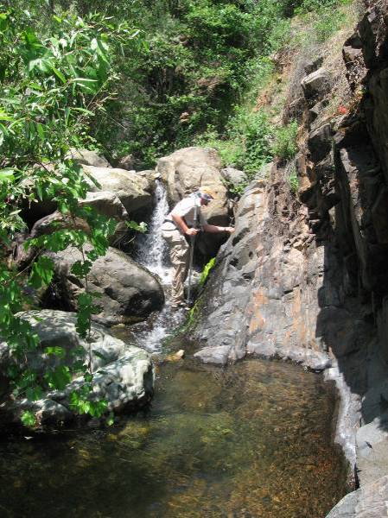
Breeding habitat at the downstream end of the reach near confluence with AMPH MF 9.3 site. Eggs were located along the margin. |  | Representative habitat for Gas Canyon Creek, looking upstream.

AMPH MF 11.0 Canyon Creek
Canyon Creek flowed within a narrow, steep canyon without floodplains. Bedrock and large boulders were the dominant substrates. Medium to small-sized alder and willow trees and shrubs were established within the channel, while oaks provided most of the overstory canopy. Canopy cover along the stream margins was typically high, although several open bedrock areas occurred. Suitable breeding habitat was not present.

Summer base flows were less than 5 cfs. During the breeding season (May 10 through June 5), average daily water temperatures within Canyon Creek just upstream of the confluence with the Middle Fork American River ranged from 52 ºF to 63 ºF, with an average of 58 ºF. During the month of August, average daily water temperatures ranged from 57 ºF to 67 ºF, with an average of 62 ºF. Non-native aquatic predators were not observed.

AMPH MF 11.0 CANYON CREEK
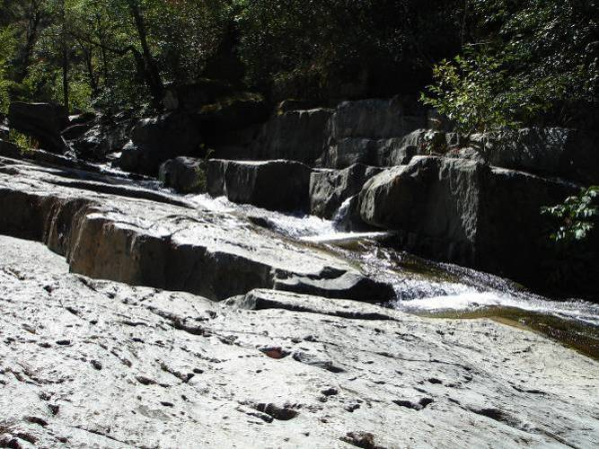 | 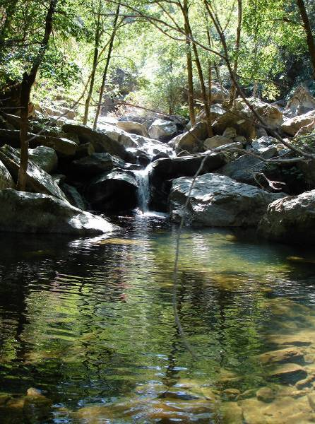
Representative bedrock cascade habitat, looking upstream. |  | Representative cascade-pool habitat, looking upstream.

AMPH MF 14.1 Otter Creek
Otter Creek was a perennial stream approximately 4.5 meters wide, typically with a floodplain along at least one bank. Instream habitats were predominately riffles and runs near the confluence with the Middle Fork American River. The habitat transitioned to cascades and plunge-pools as channel widths decreased upstream. Floodplains also became less frequent with increased distance upstream. Riparian vegetation was dominated by large to medium-sized willow, cottonwood, and alder trees and shrubs. Canopy cover along the stream margins was usually greater than 50%. Boulder and cobble were the dominant substrates in downstream reaches, while bedrock and boulders dominated further upstream. High quality breeding locations were present along the stream margins of runs in the downstream portions of the creek.

During the breeding season (May 10 through June 5), average daily water temperatures within Otter Creek just upstream of the confluence with the Middle Fork American River ranged from 54 ºF to 70 ºF, with an average of 62 ºF. Flows were less than 2 cfs. During the month of August, flows were less than 1 cfs, and average daily water temperatures ranged from 62 ºF to 76 ºF, with an average of 68 ºF. Observed non-native predators included crayfish.

AMPH MF 14.1 OTTER CREEK
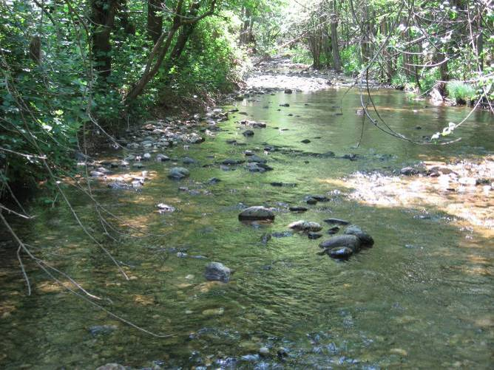 | 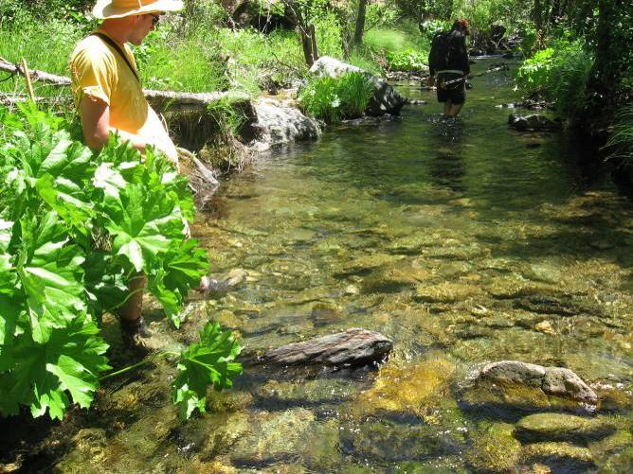
Representative habitat for Otter Creek, looking upstream. | Representative habitat along the edges of a run, looking upstream.

AMPH MF 17.0 Jesse Canyon
Jesse Canyon flowed within a steep, narrow canyon. The channel was primarily bedrock with waterfalls and chutes. Alder and willow trees and shrubs lined the channel. Suitable breeding habitat was not observed within the site.

Flow during the site visit in October was less than 0.5 cfs. Non-native aquatic predators were not observed.

AMPH MF 17.0 JESSE CANYON
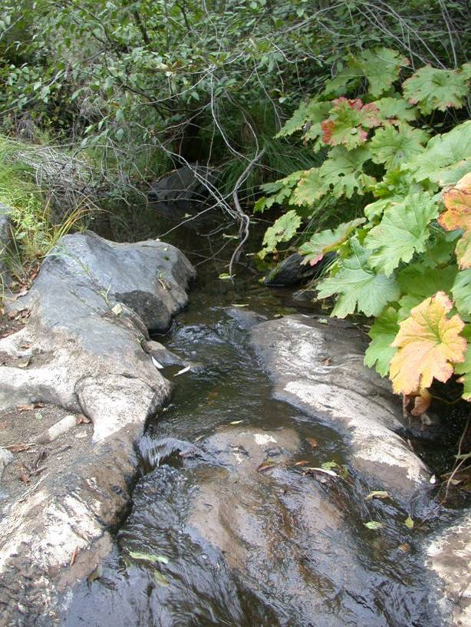 | 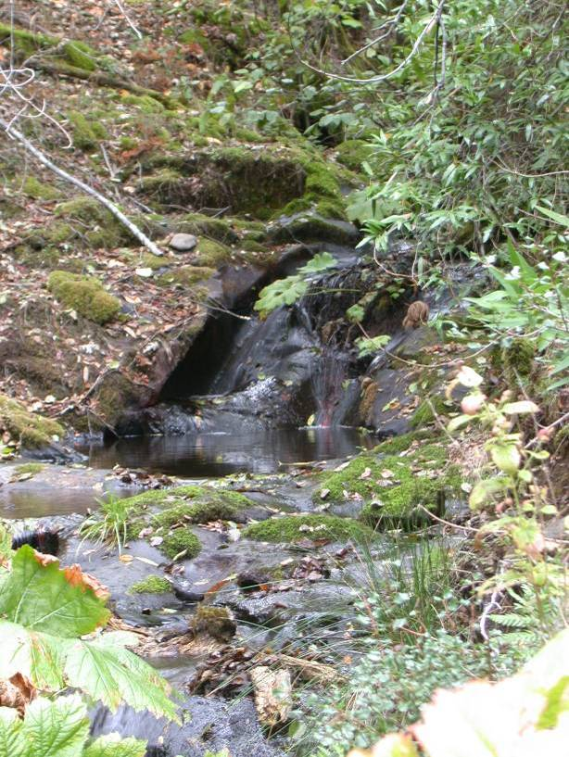
Representative habitat for Jesse Creek.

AMPH MF 18.1 Pond Creek
Pond Creek was located within a steep, narrow canyon. The channel was primarily bedrock with waterfalls and chutes. Alder and willow trees and shrubs lined the channel. Suitable breeding habitat was not observed within the site.

Flow during the site visit was less than 0.5 cfs. Non-native aquatic predators were not observed.

AMPH MF 18,1 POND CREEK
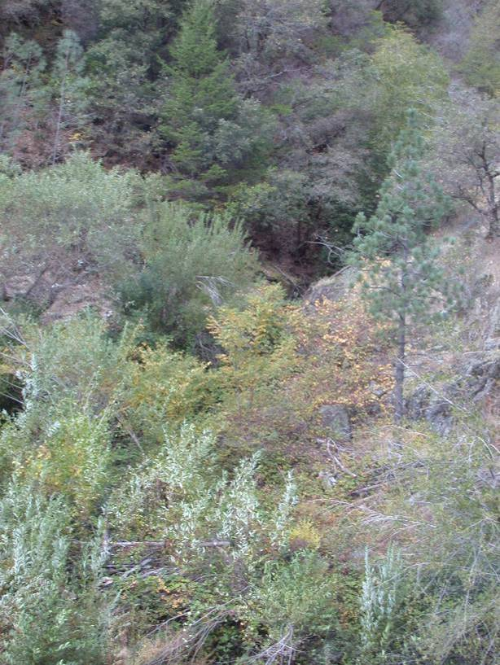 | 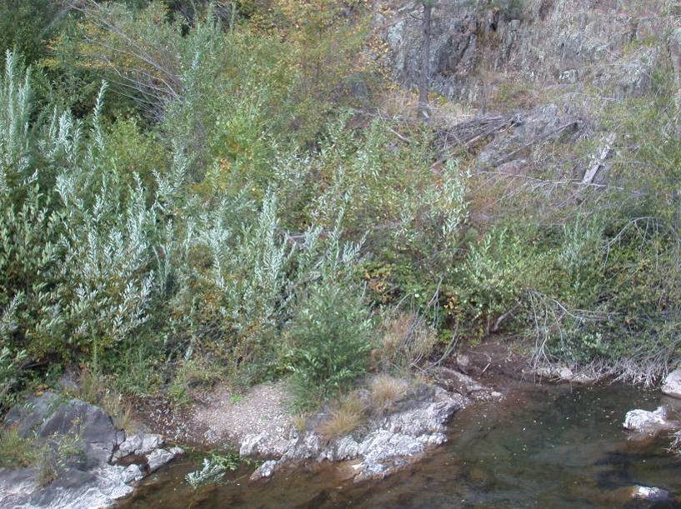
Representative habitat for Pond Creek. |  | Pond Creek at the confluence with the Middle Fork American River.

AMPH MF 21.0 Volcano Canyon Creek
Volcano Canyon Creek was a small perennial creek (approximately 4.5 meters wide) flowing within steep canyon walls. Instream habitats were dominated by cascades and step-pools with bedrock and large boulders as the dominant substrates. Small to medium-sized alder and willow trees and shrubs were present in the channel. Canopy cover along the stream margins was generally high, with several open bedrock sections. Suitable breeding habitat was not observed within the site.

Flows during the breeding season and August field surveys were less than 1 cfs. Non-native aquatic predators were not observed.

AMPH MF 21.0 VOLCANO CANYON CREEK
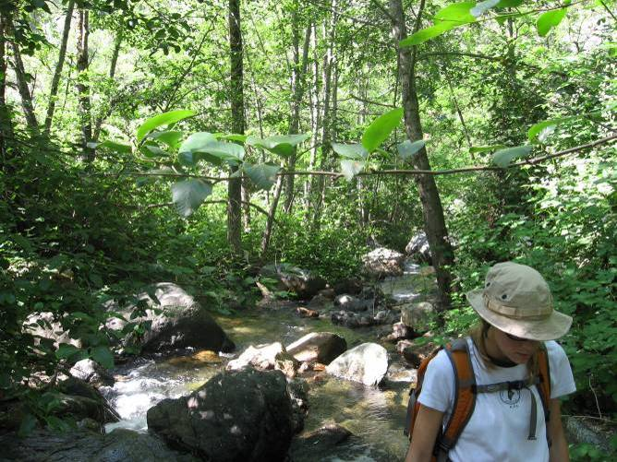 | 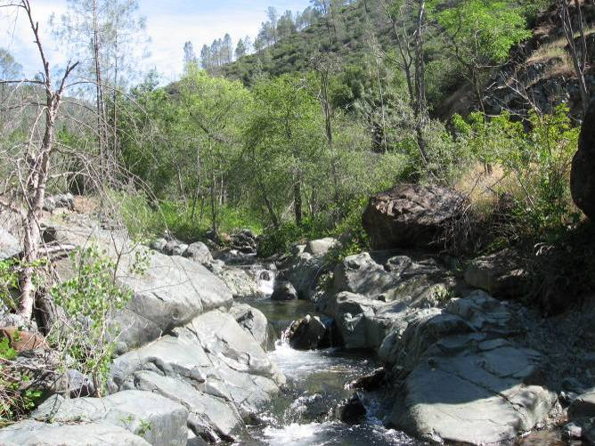
Representative habitat for Volcano Canyon Creek, looking downstream. |  | Representative open bedrock habitat for Volcano Canyon Creek, looking upstream.

AMPH MF 24.1 North Fork of the Middle Fork American River at Middle Fork American River Confluence
The North Fork of the Middle Fork American River was a perennial river, approximately 11 meters wide, with a floodplain present along some reaches. Instream habitats were primarily high-gradient riffles, runs and pools, with substrates of mixed bedrock, boulder and cobble sizes. Riparian vegetation was dominated by small to large-sized willow and alder trees and shrubs. The riparian canopy cover along the stream margins was generally low (less than 25%), with greater coverage in a few small areas (up to 50%). Suitable breeding habitat occurred primarily in boulder protected areas along the stream margins of runs, although suitable habitat also occurred in a few pool tailouts and along the margins of small cobble bars in the downstream portion of the site.

During the breeding season (May 10 through June 5), average daily water temperatures within the North Fork of the Middle Fork American River 2.3 miles upstream from the confluence with the Middle Fork American River ranged from 53 ºF to 70 ºF, with an average of 53 ºF. Flows were approximately 85 cfs. During the month of August, flows were approximately 20 cfs, and water temperatures ranged from 54 ºF to 76 ºF, with an average daily water temperature of 70 ºF. Crayfish were the only non-native predator observed. Brown trout are known to be present, although none were observed during the field surveys.

AMPH MF 24.1 NORTH FORK OF THE MIDDLE FORK AMERICAN RIVER AT MIDDLE FORK AMERICAN RIVER CONFLUENCE
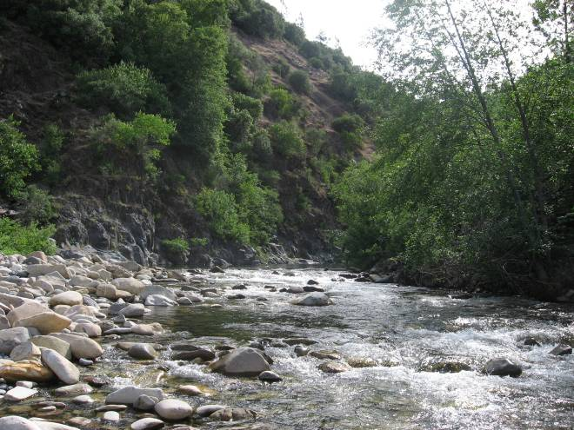 | 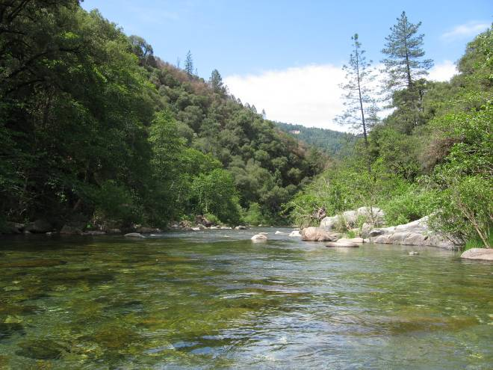
Potential breeding habitat along the margin of the cobble bar, looking upstream. |  | Representative habitat for the Middle Fork American River, looking downstream.

Middle Fork American River, RM 26.2 - 35.3 (Ralston Afterbay to Middle Fork Interbay)
Four sites were surveyed in this reach of the Middle Fork American River. These sites included AMPH MF 26.2, AMPH MF 29.4, AMPH MF 30.4, and AMPH MF 35.3. Physical habitat characteristics of each site are summarized below.

The Middle Fork American River between Ralston Afterbay and Middle Fork Interbay was confined within steep bedrock valley walls and was dominated by high-gradient habitats, such as step-pools, high-gradient riffles and runs. Exposed bedrock commonly occurred at the hillslope toe-bankfull width interface. The channel bed was comprised of boulders and cobbles, with frequent bedrock outcrop exposures. Sediment storage in the form of infrequent channel bars was observed throughout the reach, often lined with riparian vegetation, although the size of bars was typically small (PCWA 2007). Riparian vegetation along the stream margins was dominated by mature alders and willows. Canopy cover was typically low (less than 25%), with up to 75% cover in some locations. Suitable breeding habitat occurred primarily in boulder-protected margins of runs and cobble-dominated pool tailouts. Suitable breeding habitat was limited in the upper portion of the reach.

Flows in the reach are regulated by releases from Middle Fork Interbay Dam. During the breeding season (May 10 through June 5), flows were approximately 30 cfs to 43 cfs. During the month of August, flows ranged from approximately 18 cfs to 26 cfs (Gage No. PF-2). Average daily water temperatures warmed with distance downstream from Middle Fork Interbay to Ralston Afterbay. During the breeding season, average daily water temperatures immediately below Middle Fork Interbay ranged from 45 ºF to 57 ºF, with an average of 48 ºF. Just upstream of Ralston Afterbay, average daily water temperatures ranged from 55 ºF to 69 ºF, with an average of 63 ºF. During the month of August, average daily water temperatures ranged from 46 ºF to 50 ºF, with an average of 47 ºF immediately below Middle Fork Interbay. Upstream of Ralston Afterbay, average daily water temperatures ranged from 62 ºF to 73 ºF, with an average of 68 ºF. Non-native predators, such as brown trout and crayfish, were observed in the reach.

AMPH MF 26.2 MIDDLE FORK AMERICAN RIVER ABOVE RALSTON AFTERBAY
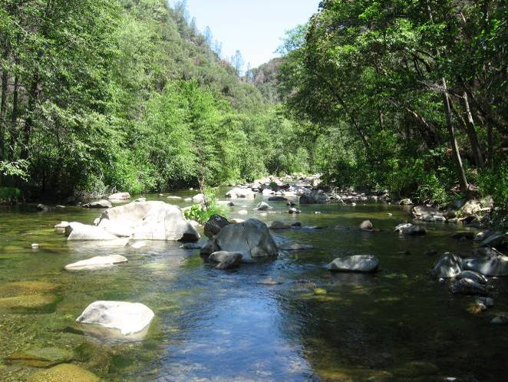 |  | 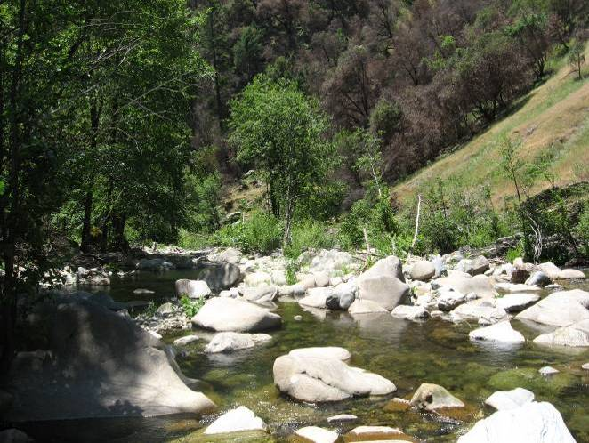
Representative habitat for Middle Fork American River, looking upstream. Potential breeding habitat occurred along edgewater of the run. | Breeding habitat occurred in the pool tailout, looking downstream. Red flagging marks an egg-laying site.

AMPH MF 29.4 MIDDLE FORK AMERICAN RIVER
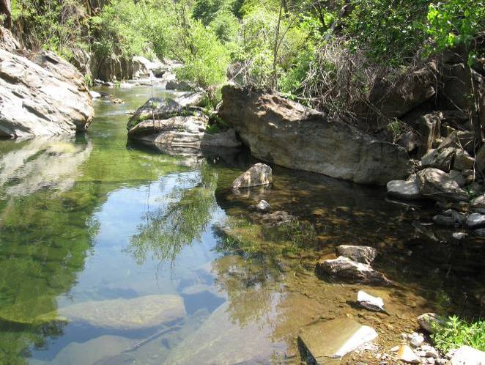 |  | 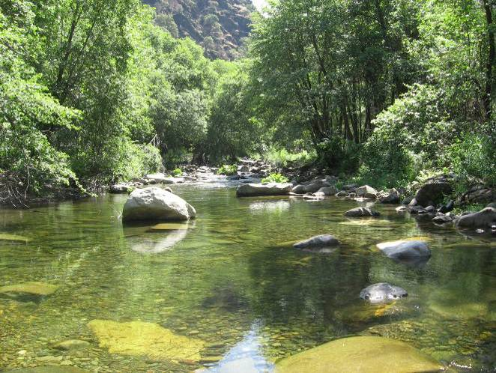
Representative habitat for the Middle Fork American River, looking upstream. | Potential breeding habitat occurred behind the boulders and along the stream edge in the run, looking upstream.

AMPH MF 30.4 MIDDLE FORK AMERICAN RIVER
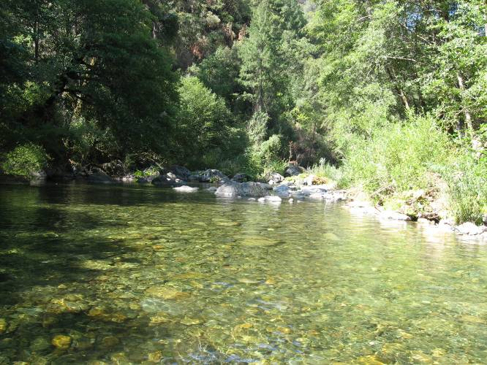 |  | 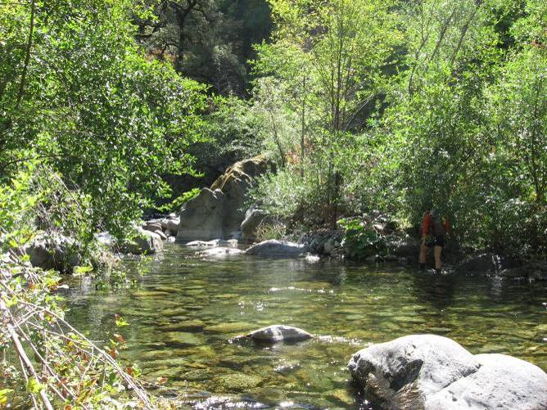
Potential breeding habitat along river right bank, looking downstream. | Representative run habitat, looking upstream.

AMPH MF 35.3 MIDDLE FORK AMERICAN RIVER DOWNSTREAM OF MIDDLE FORK INTERBAY
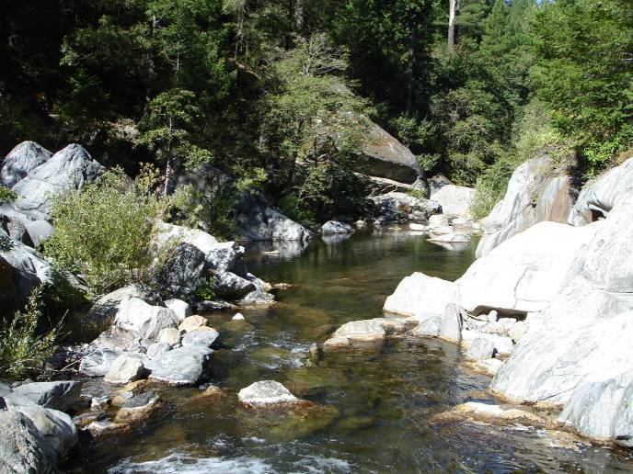 | 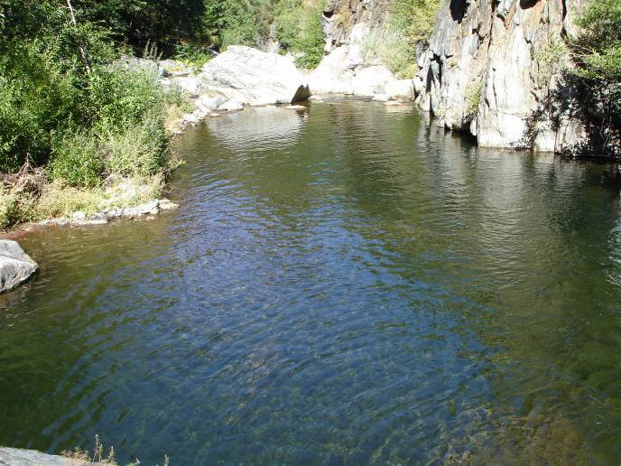
Representative habitat, looking downstream. | Representative pool habitat, looking downstream.

Surveyed Tributaries to the Middle Fork American River, RM 26.2 – 35.3
One unregulated tributary to the Middle Fork American River between Ralston Afterbay and Middle Fork Interbay was surveyed. Physical habitat characteristics of this tributary are described below.

AMPH MF 30.4 Brushy Canyon Creek
Brushy Canyon Creek was a small, narrow bedrock stream within steep canyon walls dominated by high-gradient cascades and plunge-pools. The stream was approximately 4.5 meters wide, with no floodplains present. An oak overstory shaded the channel. Potential breeding habitat was not observed at this site.

Flow was less than 1 cfs during the August field survey. The creek was not surveyed during the breeding season. Non-native aquatic predators were not observed.

AMPH MF 30.4 BRUSHY CANYON CREEK
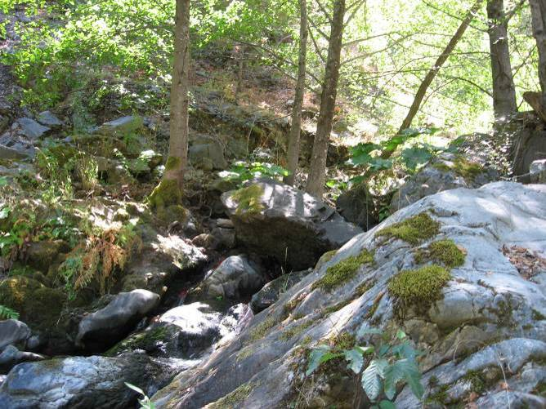 | 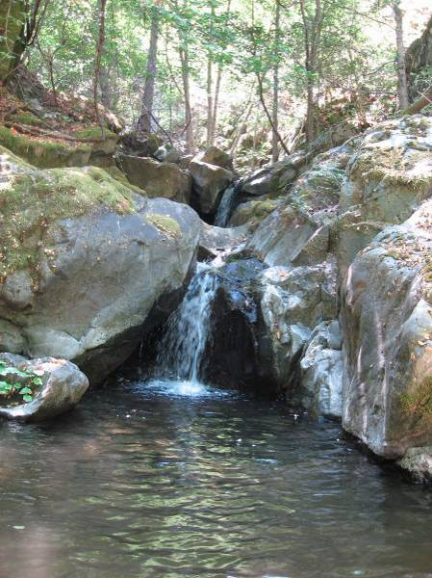
Representative habitat for Brushy Canyon Creek, looking upstream.

Middle Fork American 36.2 – 47.2 (Middle Fork Interbay to French Meadows Reservoir)
Two sites were surveyed between Middle Fork Interbay and French Meadows Reservoir. These sites included AMPH MF 36.2 and AMPH MF 39.7. Physical habitat characteristics of this reach are described below.

The Middle Fork American River between Middle Fork Interbay and French Meadows Reservoir was steep and confined within a narrow canyon with high-gradient habitats and bedrock and boulder substrates. Few sediment deposits were observed within or near the active channel. Riparian vegetation along the stream margins was patchy, with sparse vegetation in some areas and denser cover in others. Suitable breeding habitat was limited within this reach.

Flows within this reach are regulated by French Meadows Dam. Except for relatively infrequent spill events during wetter years and powerhouse maintenance periods, releases are the required minimum instream flows. During the breeding season (May 10 through June 5), flows ranged between 39 cfs and 80 cfs. During the month of August, flows were between 14 cfs and 16 cfs. The maximum average daily flow during the preceding winter and spring was 772 cfs (Gage No. 11427760). Immediately downstream of French Meadows Dam, average daily water temperatures ranged from 43 ºF to 54 ºF, with an average of 47 ºF during the breeding season. Just upstream of Middle Fork Powerhouse at RM 36.1, average daily water temperatures ranged from 51 ºF to 66 ºF, with an average of 58 ºF. During the month of August, average daily water temperatures ranged from 46 ºF to 56 ºF, with an average of 50 ºF immediately below French Meadows Dam. Upstream of Middle Fork Powerhouse, the August average daily water temperatures ranged from 60 ºF to 70 ºF, with an average of 65 ºF. Non-native predators were not observed during the field surveys.

AMPH MF 36.2 MIDDLE FORK AMERICAN RIVER UPSTREAM OF MIDDLE FORK INTERBAY
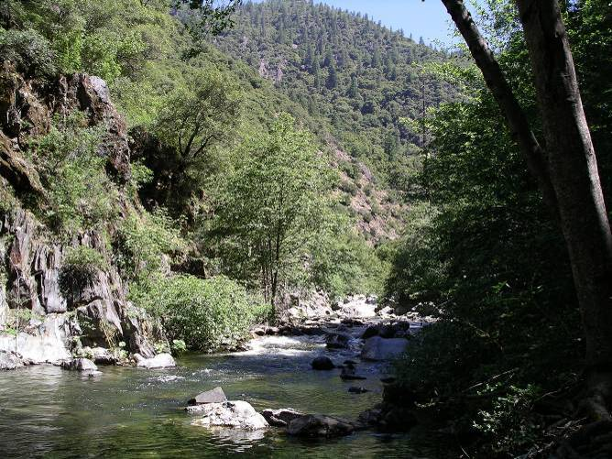 | 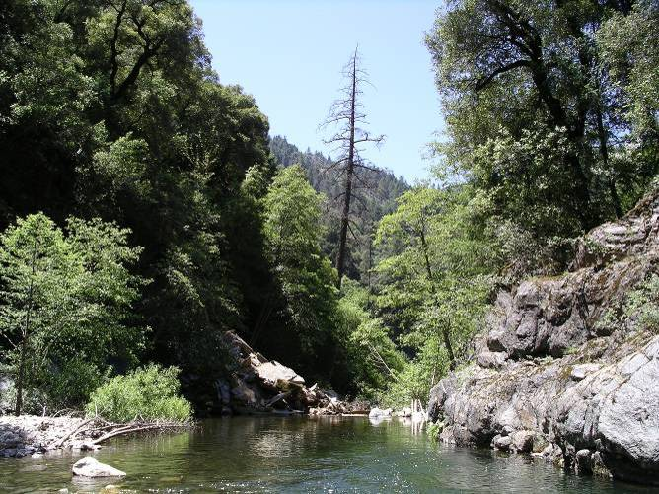
Representative habitat for Middle Fork American River, looking upstream. Breeding habitat occurred along edgewater of the run. |  | Small area of potential breeding habitat along cobble bar left-side of photo (shown with white arrow), looking downstream.

AMPH MF 39.7 MIDDLE FORK AMERICAN RIVER AT DUNCAN CREEK
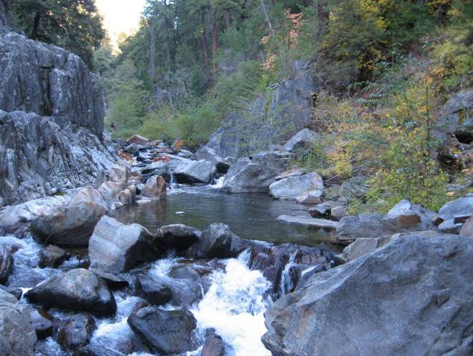 | 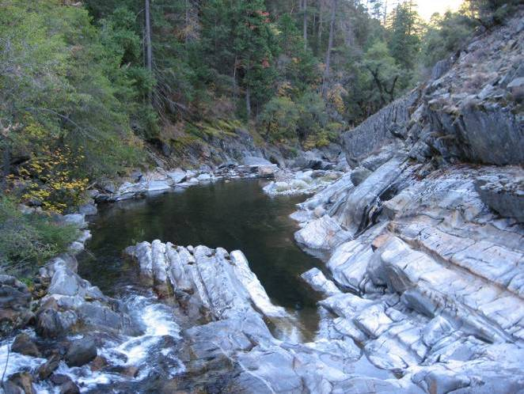
Representative habitat for the Middle Fork American River at the Duncan Creek confluence. |  | Representative pool habitat along the Middle Fork American River at the Duncan Creek confluence.

Surveyed Tributaries to the Middle Fork American River, RM 36.2 – 47.2
One tributary between Middle Fork Interbay and French Meadows Reservoir was surveyed. Physical habitat characteristics of this tributary, Duncan Creek, are described below.

AMPH MF 39.7 Duncan Creek
Duncan Creek was a steep, confined, bedrock-dominated stream with waterfalls and cascades interrupted by plunge pools. Some riparian vegetation was present, mostly forbs, with a few moderately-sized alders along the channel margins. Canopy cover along the stream margins was low. Suitable breeding habitat was not present in Duncan Creek at the confluence.

Average daily flows during the winter and spring preceding the site surveys in Duncan Creek below the diversion (Gage No. 11427750) ranged between 266 cfs and the minimum instream flow, which was less than 1 cfs. Just upstream of the Middle Fork American River confluence, average daily water temperatures in Duncan Creek ranged from 48 ºF to 61 ºF, with an average of 54 ºF during the breeding season (May 10 through June 5). During the month of August, average daily water temperatures ranged from 56 ºF to 68 ºF, with an average of 61 ºF

AMPH MF 39.7 DUNCAN CREEK AT THE MIDDLE FORK AMERICAN RIVER
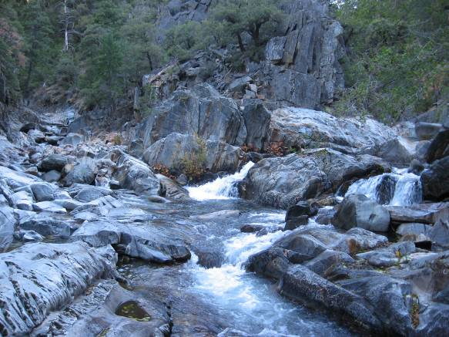 | 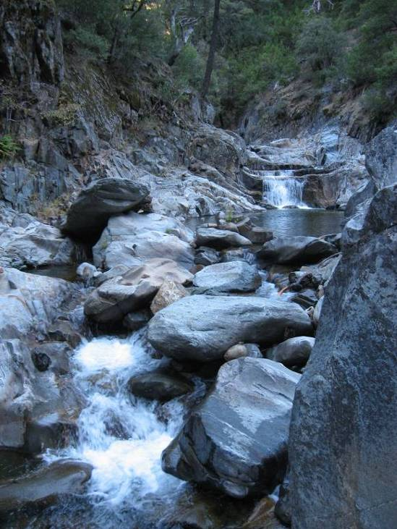

Rubicon River, RM 0.0 – 30.3 (Ralston Afterbay to Hell HOLE Reservoir)
Seven sites were surveyed along the Rubicon River. These sites included AMPH R 1.2, AMPH R 3.5, AMPH R 5.2, AMPH R 14.3, AMPH R 20.9, AMPH R 22.6, AMPH R 25.7. Physical habitat characteristics of the Rubicon River are summarized below.

The Rubicon River was a perennial river, typically confined within steep canyon walls. The channel was approximately 20 meters wide, often with a floodplain or large bar along at least one bank. Instream habitats were primarily riffle-run and riffle-pool sequences with cobble bars where valley widths were greater and higher-gradient step-pools in narrow bedrock-controlled sections. Boulder, cobble and bedrock were the dominant substrates. Riparian vegetation was patchy, often established on the bars along the low flow channel margins, and dominated by small to medium-sized willow and alder trees and shrubs. Canopy cover was typically less than 25%, although it was higher in localized areas. A four-mile reach immediately downstream of Hell Hole Dam was very different from the remainder of the river downstream. This reach was widened and aggraded by the failure of Hell Hole Dam in 1964. The valley bottom was transformed from a narrow V-shape to a wider U-shaped cross-sectional profile with low stream gradient. The AMPH R 25.7 site is located within this section of the river. High quality breeding locations were available throughout the river, including large cobble bars with associated slow velocity areas, shallow pool tailouts, and wide runs with shallow cobble areas along the margins.

Flows within this reach are regulated by Hell Hole Reservoir. The maximum average daily flow immediately below Hell Hole Dam during the winter and spring preceding the site surveys was 69 cfs. During the spring breeding season (May 10 through June 5) and the month of August, flows ranged from 22 cfs to 24 cfs (Gage No. 11428800). Just upstream of Ralston Afterbay, flows during the breeding season ranged from approximately 80 cfs to 120 cfs. During August, flows were approximately 50 cfs (Gage No. P-F3). Average daily water temperatures generally increased with distance downstream from the dam. Releases from Hell Hole Reservoir were cooler than 50 ºF, with little variability. During the spring breeding season, average daily water temperatures immediately below Hell Hole Dam ranged from 43 ºF to 44 ºF. During the month of August, average daily water temperatures ranged from 44 ºF to 46 ºF. Approximately three miles downstream, below the South Fork Rubicon River confluence, average daily water temperatures warmed to 56 ºF (ranging between 50 ºF and 62 ºF) during the breeding season. In August, average daily water temperatures at this location ranged between 57 ºF and 65 ºF, with an average of 61 ºF. Just upstream of Ralston Powerhouse, the maximum average daily water temperature during the breeding season was 72 ºF, with an average of 65 ºF. During the month of August, average daily water temperatures ranged from 68 ºF to 78 ºF, with an average of 73 ºF. Brown trout were the only observed non-native predator. As crayfish were observed in surrounding reaches, they are likely also present within these surveyed sites.

AMPH R 1.2 RUBICON RIVER
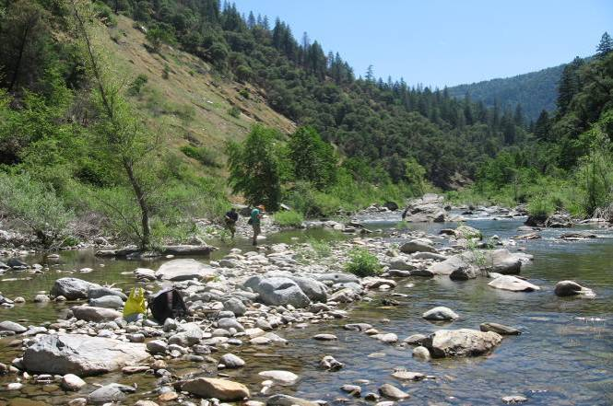 |  |  | 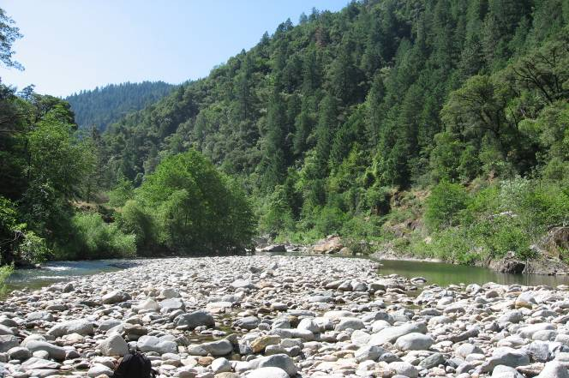
Representative run habitat for the Rubicon River, looking upstream. Breeding occurred in shallow overbank area and edge of run along left-side of photo. |  | Breeding habitat in the pool tailout backwater at upstream end of bar, looking upstream.
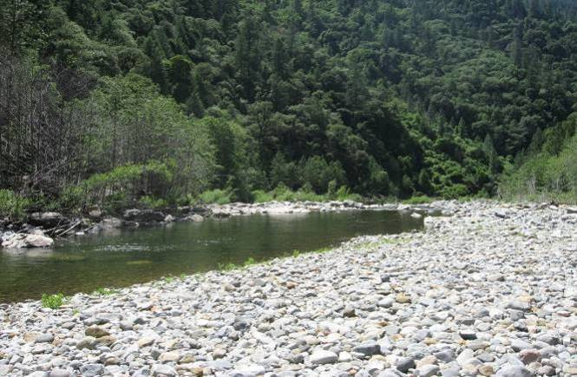
 | Representative deep-run breeding habitat, looking downstream.

AMPH R 3.5 RUBICON RIVER AT LONG CANYON CREEK
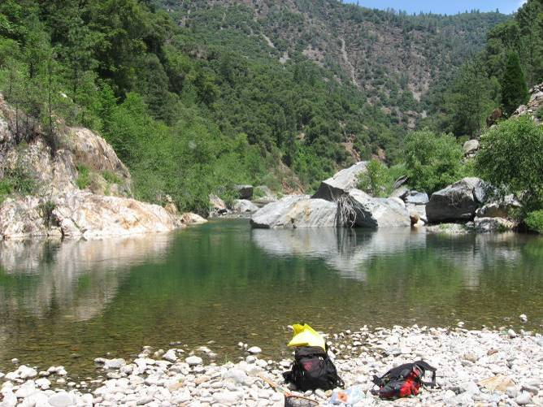 | 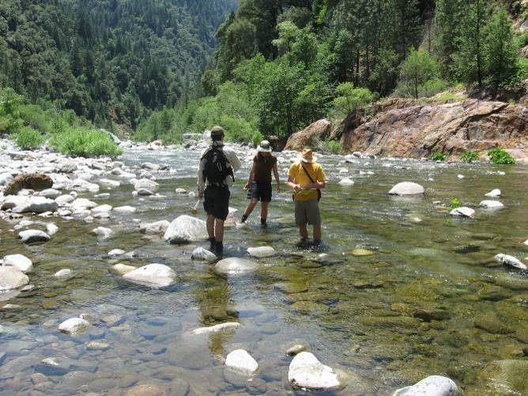
Breeding habitat in pool tailout backwater at upstream end of bar, looking upstream. | Representative habitat for the Rubicon River, looking downstream. Breeding occurred along edge of run.

AMPH R 5.2 RUBICON RIVER AT PILOT CREEK
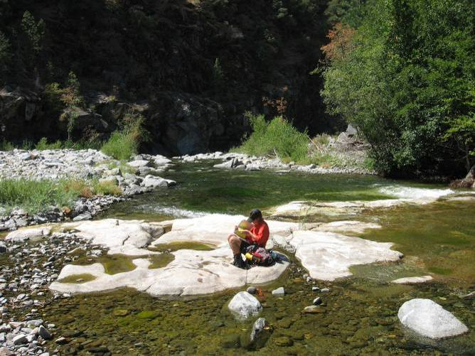 |  | 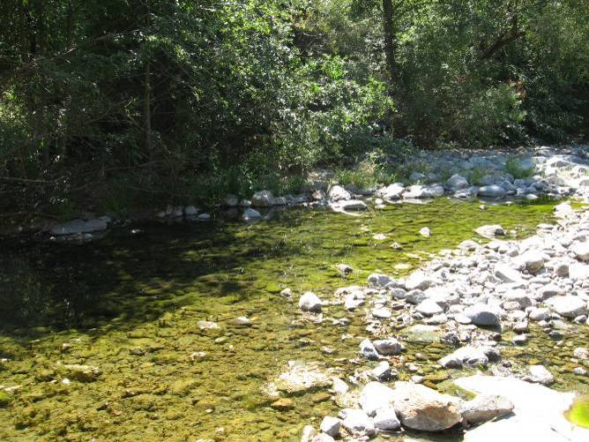
Representative habitat for the Rubicon River, looking downstream. Breeding occurred along edge of run. | Breeding habitat in pool tailout backwater at upstream end of bar, looking upstream.

AMPH R 14.3 RUBICON RIVER
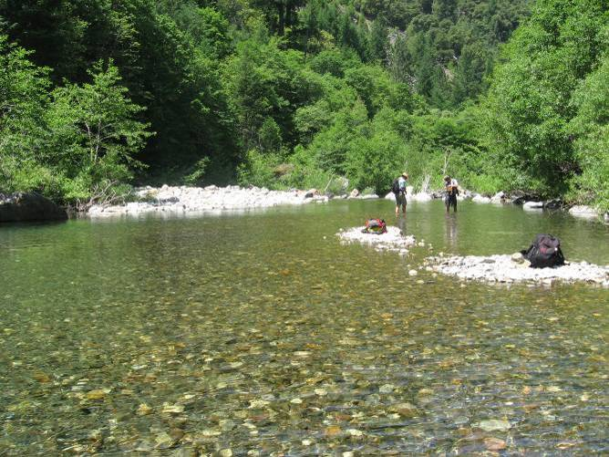 |  | 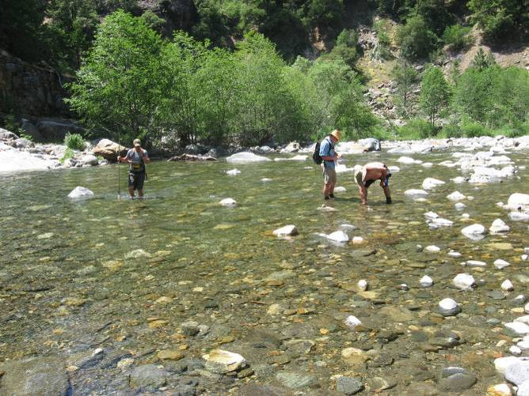
Breeding habitat on the submerged mid-channel cobble bar, looking downstream. | Representative pool/run habitat for the Rubicon River, looking downstream. Breeding occurred along edge of run, right-side of photo.

AMPH R 20.9 RUBICON RIVER BELOW ELLICOT BRIDGE
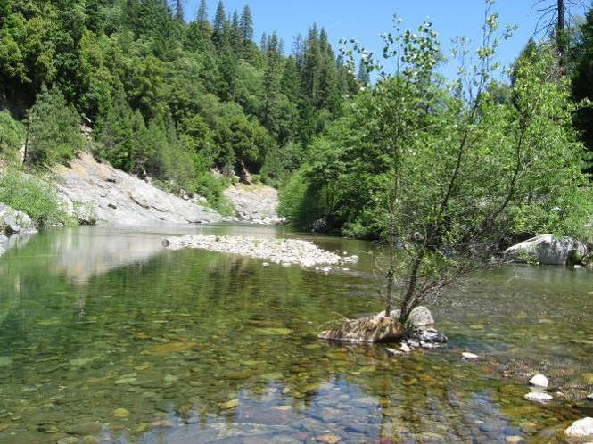 | 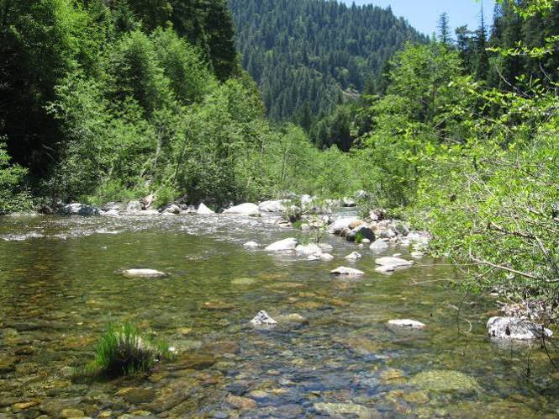
Representative habitat for the Rubicon River, looking upstream. |  | Potential breeding habitat, looking downstream.

AMPH R20.9 RUBICON RIVER BELOW ELLICOT BRIDGE CONTINUED
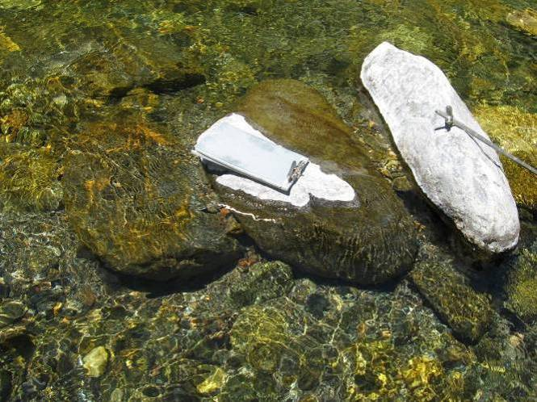

Breeding on lee-side of imbricated boulders (indicated with the white arrow) in mid-channel, looking cross-stream.

AMPH R 22.6 RUBICON RIVER AT SOUTH FORK RUBICON RIVER CONFLUENCE
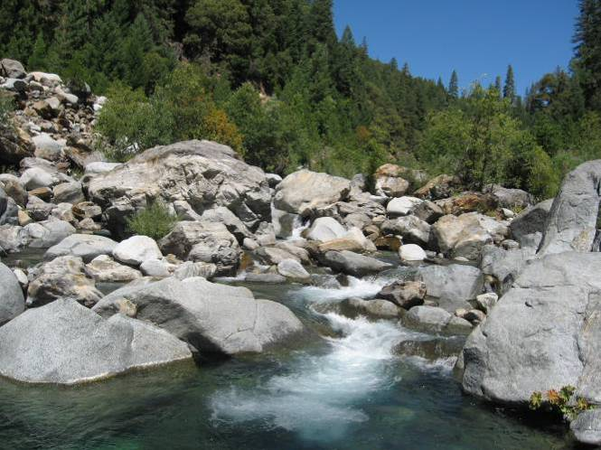 | 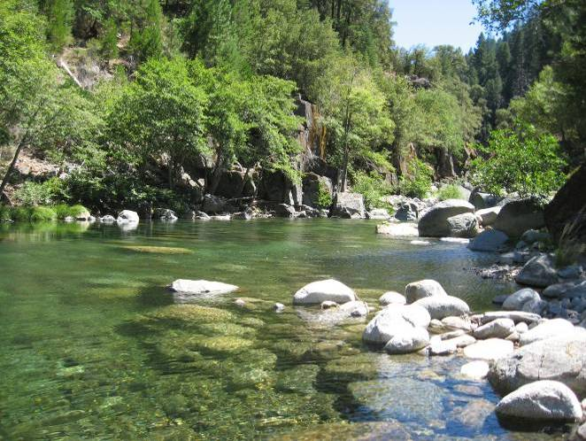
Representative cascade habitat, looking upstream. | Potential breeding habitat along the edge of run, looking downstream.

AMPH R 25.7 RUBICON RIVER BELOW HELL HOLE RESEVOIR
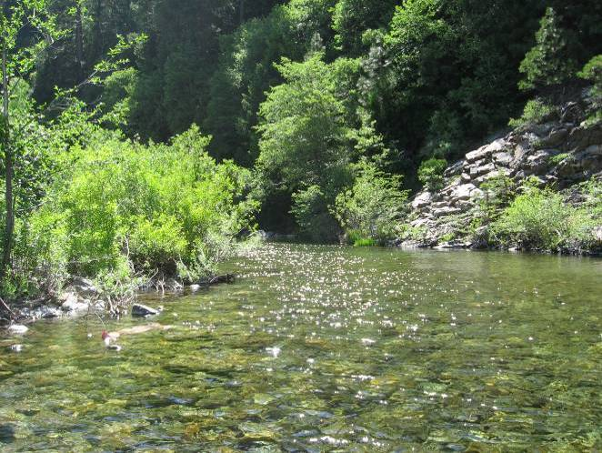 | 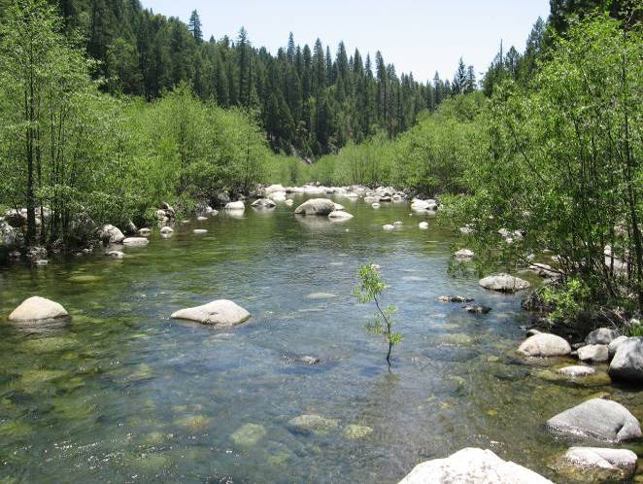
Representative habitat for the Rubicon River, looking downstream. |  | Potential breeding habitat along the edge of run, looking downstream.

Surveyed Tributaries to the Rubicon River, RM 0.0 – 30.3
Two tributaries to the Rubicon River were surveyed, Long Canyon Creek and Pilot Creek. Physical habitat characteristics of these sites are summarized below.

AMPH R 3.5 Long Canyon Creek at Rubicon River
Long Canyon Creek was a perennial stream, confined within steep canyon walls and dominated by high-gradient instream habitats such as high-gradient riffles, cascades and plunge-pools. The channel was approximately 10 meters wide with no floodplains. Riparian vegetation was dominated by small to medium-sized willow and alder shrubs and trees, and canopy cover along the stream margin was typically less than 25%. Boulder and bedrock were the dominant particle sizes, with some cobble-sized material present in depositional areas. A few larger pools close to the confluence with the Rubicon River had potential breeding habitat in boulder-protected edgewater; however, suitable breeding habitat was not observed upstream.

Flow within Long Canyon Creek is diverted on North and South Fork Long Canyon Creeks primarily in the winter and spring. Diversion does not usually occur in the later summer and early fall, resulting in natural flows during this time. During the breeding season (May 10 through June 5), flows ranged from approximately 22 cfs to 40 cfs (Gage No. P-F4). Average daily water temperatures just upstream of the confluence with the Rubicon River during the breeding season ranged from 57 ºF to 62 ºF, with an average of 59 ºF. During the month of August, average daily water temperatures ranged from 66 ºF to 78 ºF, with an average of 72 ºF. Flows were less than 5 cfs during the August field surveys. Non-native predators were not observed during the field surveys.

AMPH R 3.5 LONG CANYON CREEK AT RUBICON RIVER
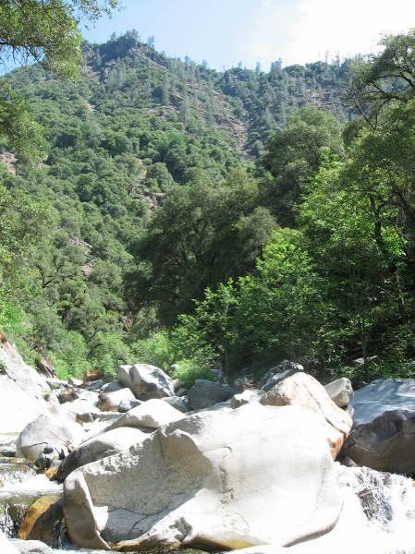 |  | 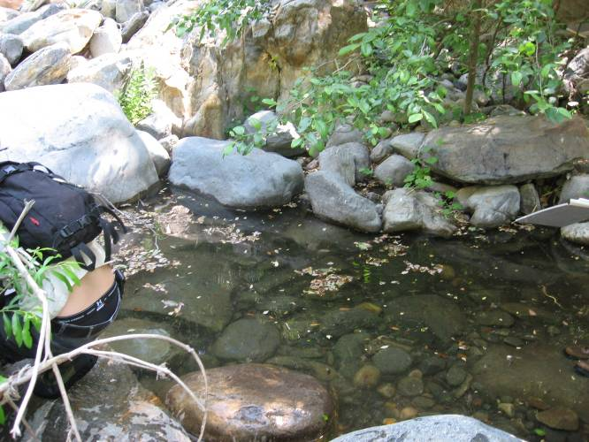
Representative cascade habitat for Long Canyon Creek, looking upstream. |  |  | Potential breeding habitat approximately 300 meters upstream of confluence with R 3.5.
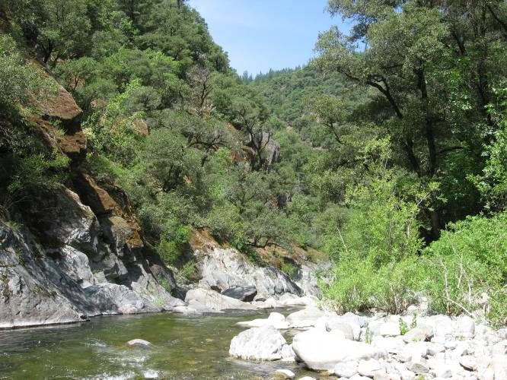
 | Representative run habitat on upper Long Canyon Creek, looking downstream.

AMPH R 5.2 Pilot Creek
Pilot Creek was a narrow (approximately 4.5 meters wide) perennial stream confined within steep bedrock canyon walls. Instream habitats were primarily high-gradient cascades and plunge-pools, although a few lower-gradient sections with high-gradient riffles occurred. Riparian vegetation was dominated by small to medium-sized willow and alder trees, with moderate canopy coverage along the stream margins. Potential breeding habitat was limited and associated with boulder-protected stream margins.

Flow in Pilot Creek was regulated by Sacramento Municipal Utility District (SMUD) at Stumpy Meadows Reservoir (FERC Project No. 2101). During the breeding season (May 10 through June 5), average daily water temperatures just upstream of the confluence with the Rubicon River ranged from 61 ºF to 65 ºF, with an average of 58 ºF. Flows in Pilot Creek at this time were less than 2 cfs. During the month of August, average daily water temperatures ranged from 58 ºF to 68 ºF, with an average of 62 ºF. Flow was less than 1 cfs during the August field surveys. Non-native predators were not observed during the site surveys.

AMPH R 5.2 PILOT CREEK
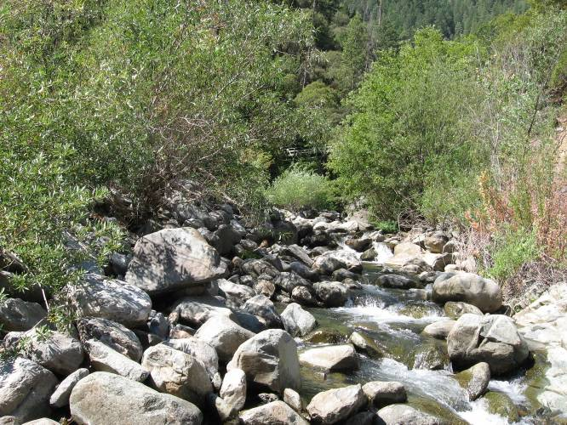 | 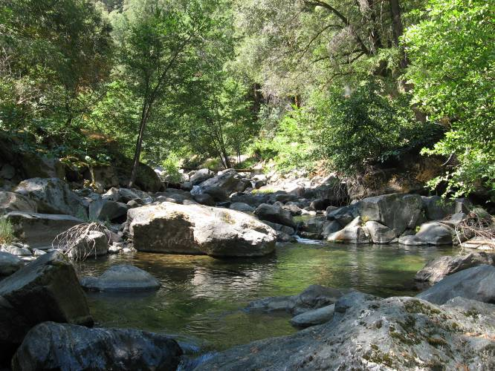
Representative low-gradient habitat near the Rubicon River confluence, looking upstream. |  | Potential breeding habitat located behind boulders and in backwaters of pool, looking upstream.
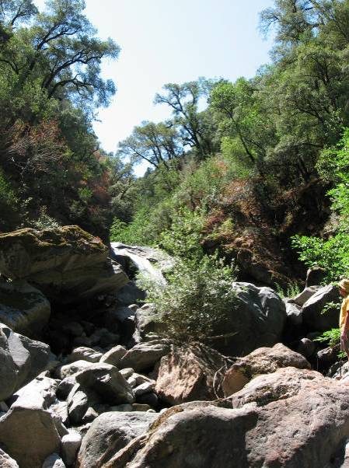
Representative high-gradient habitat for Pilot Creek, looking upstream.

Long Canyon Creek, RM 9 – 11.4
Two sites were surveyed along Long Canyon Creek, including one unregulated tributary. An incidental site visit was conducted at Wallace Creek. Physical habitat characteristics of each of the sites, including Wallace Creek, Long Canyon Creek at Ramsey Crossing, and at the confluence of the North and South Forks Long Canyon Creek including upstream each of the forks, are described below.

AMPH LC 5.6 Wallace Creek
Wallace Creek was a small stream (approximately 6 meters wide) located within steep canyon walls with no flood plains. The channel was very high-gradient, dominated by large boulders and bedrock waterfalls and chutes. Small to medium-sized alder and willow trees and shrubs were present in the channel, with oaks providing the overstory. Canopy cover along the stream margins was typically high. Potential breeding habitat was not observed at this site.

During the breeding season (May 10 through June 5), flows were less than 1 cfs and average daily water temperatures just upstream of the confluence with Long Canyon Creek (RM 6.8) ranged from 49 ºF to 56 ºF, with an average of 52 ºF. During the month of August, flows were less than 1 cfs and average daily water temperatures ranged from 58 ºF to 68 ºF, with an average of 62 ºF. Non-native aquatic predators were not observed.

AMPH LC 5.6 WALLACE CREEK
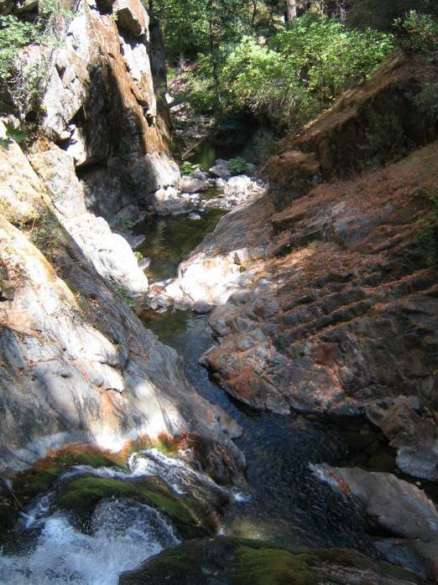 | 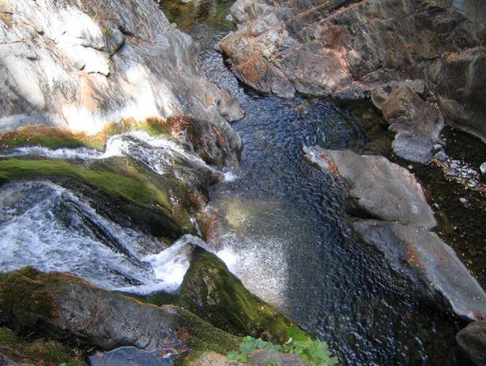
Representative bedrock cascade habitat, looking downstream at plunge pools.

AMPH LC 9.0 Long Canyon Creek (Ramsey Crossing)
Long Canyon Creek was a relatively narrow (approximately 6 meters wide) perennial stream confined within steep canyon walls with no floodplains. Instream habitats were primarily high-gradient cascades and step-pools, although some lower-gradient sections with runs and riffles occurred. Boulder and bedrock were the dominant substrates with some cobbles in small depositional areas. Riparian vegetation was dominated by small to medium sized willow and alder trees and shrubs, with low to moderate canopy cover along the stream margins. Suitable breeding habitat was rare, occurring in only a few larger pools that had boulder-protected edgewater.

Flow within Long Canyon Creek was diverted on North and South Fork Long Canyon creeks primarily in the winter and spring. Diversion usually does not occur in the later summer and early fall, resulting in natural flows during this time. Winter and spring flows peaked at 216 cfs, while during the breeding season (May 10 through June 5), flows were approximately 11 cfs (Gage No. P-F5). Average daily water temperatures within Long Canyon Creek just upstream of the confluence with Wallace Canyon (RM 6.8) during the breeding season ranged from 51 ºF to 60 ºF, with an average of 55 ºF. During the month of August, flows were less than 1 cfs and average daily water temperatures ranged from 59 ºF to 70 ºF, with an average of 64 ºF. Brown trout were observed during the field surveys.

AMPH LC 9.0 LONG CANYON CREEK - RAMSEY CROSSING
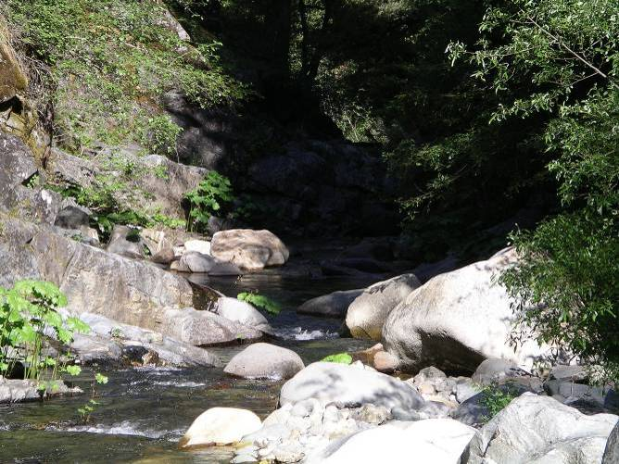 |  | 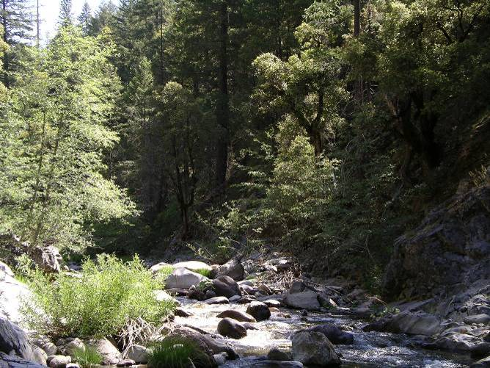
Representative habitat for Long Canyon Creek, looking downstream. | Representative run habitat for Long Canyon Creek, looking upstream.

AMPH LC 11.4 Confluence of North Fork and South Fork Long Canyon Creeks
This site is located at the confluence of the North and South Forks of Long Canyon creeks, and includes surveys along both tributaries. Both forks were perennial within the surveyed site, although sections were intermittent farther upstream. Each stream was relatively small, with channel widths less than 10 meters wide in the majority of the reach, and dominated by cascades and plunge-pools. Long Canyon Creek downstream of the confluence was narrow (less than 15 meters wide), and dominated by larger cascades and pools. Substrates were primarily bedrock, boulder and cobble, and floodplains were poorly developed or absent both upstream and downstream of the confluence. Riparian canopy coverage along the stream margins was typically high. Willows and alders were the primary shade providers with a fir and pine overstory in some areas. Suitable breeding habitat was rare.

Flow within Long Canyon Creek was diverted on North and South Fork Long Canyon creeks primarily in the winter and spring. Diversion usually does not occur in the later summer and early fall, resulting in natural flows during this time. During the field surveys, flows were less than 5 cfs. During the breeding season (May 10 through June 5), average daily water temperatures just downstream of the North and South Forks Long Canyon creeks confluence ranged from 49 ºF to 56 ºF, with an average of 52 ºF. Water temperatures during this time period immediately below the diversion dams on both forks were slightly warmer. During the month of August, average daily water temperatures below the confluence of the forks ranged from 55 ºF to 68 ºF, with an average of 61 ºF. Water temperatures below the South Fork Long Canyon Creek diversion were slightly cooler than those below the confluence. Below the North Fork Long Canyon Creek diversion dam, the average daily water temperature was similar to those below the confluence, but maximum daily water temperatures were greater (74 ºF). Brown trout and California newts were observed during the field surveys.

AMPH LC 11.4 LONG CANYON CREEK
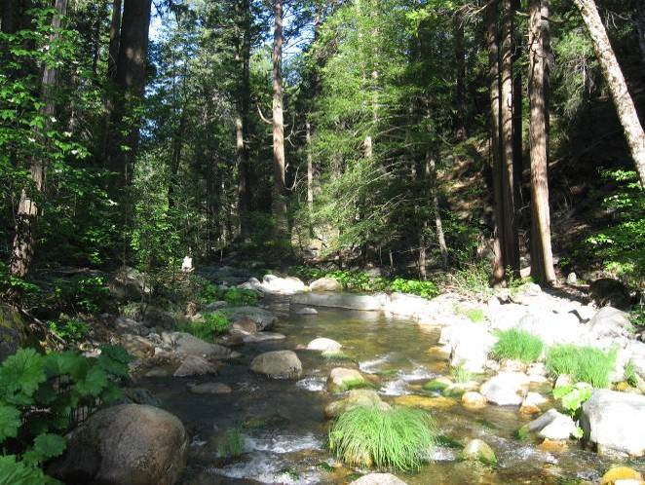 | 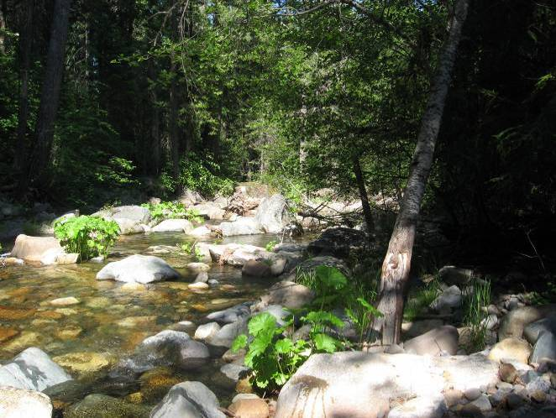
Representative habitat for North Fork Long Canyon Creek, looking downstream. |  | Representative habitat for South Fork Long Canyon Creek, looking downstream.

AMPH LC 11.4 SOUTH FORK LONG CANYON CREEK
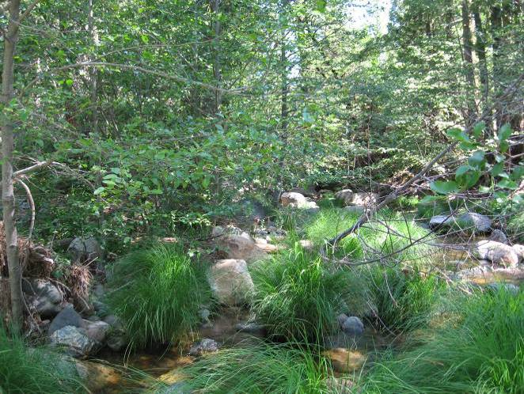 | 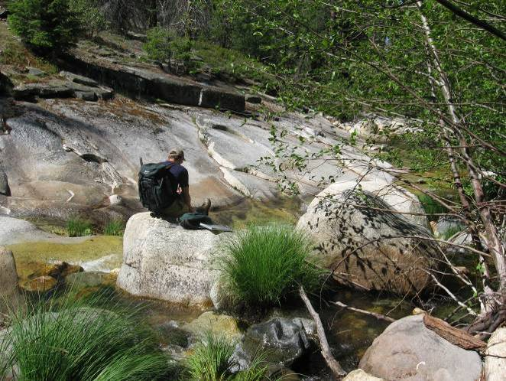
Representative habitat for South Fork Long Canyon, looking downstream.

Comparison Stream reaches
Surveys were completed on two comparison streams, the North Fork American River and the North Fork of the Middle Fork American River. Physical habitat characteristics of the survey sites along each of these rivers are described below.

North Fork American River, RM 0 – 35.7
Two mainstem sites and two tributaries were surveyed along the North Fork American River. Incidental site visits were conducted at two additional locations along the North Fork American River. Physical habitat characteristics of each of these sites are described below.

AMPH NF 21.2 North Fork American River at Middle Fork American River Confluence
The North Fork American River upstream of the confluence with the Middle Fork American River was a perennial stream that flowed within moderately steep canyon walls. The channel was approximately 15 meters wide with long deep pools and minimal floodplains, if present. Cobble point and side bars were few, though some mid-channel bars were present. Bedrock and sand were the dominant substrates. Riparian vegetation was patchy and dominated by small to medium-sized willow and alder trees and shrubs. Canopy cover was generally low. Suitable breeding areas were not present for the majority of the site due to the dominance of long deep pools and short runs.

Flows are minimally regulated within the North Fork American River by the North Fork Dam, which forms Lake Clementine. During the breeding season (May 10 through June 5), flows ranged from approximately 50 cfs to 500 cfs. Average daily water temperatures recorded at RM 21.4 ranged from 58 ºF to 74 ºF, with an average of 66 ºF. During the month of August, flows were approximately 40 cfs and average daily water temperatures ranged from 70 ºF to 80 ºF, with an average of 74 ºF. Bullfrogs (adults and tadpoles), crayfish, and smallmouth bass were observed.

AMPH NF 21.2 NORTH FORK AMERICAN RIVER AT MIDDLE FORK AMERICAN RIVER CONFLUENCE
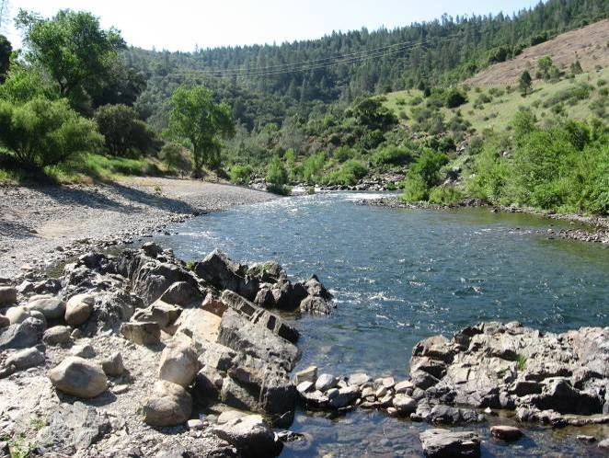 |  | 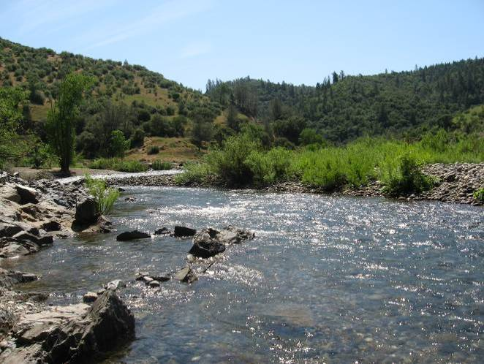
Representative habitat for the North Fork American River, looking upstream. Potential breeding habitat occurred along margin of cobble bar. | Potential breeding habitat along cobble bar margin, looking upstream.

AMPH NF 21.2 MIDDLE FORK AMERICAN RIVER AT NORTH FORK AMERICAN RIVER CONFLUENCE
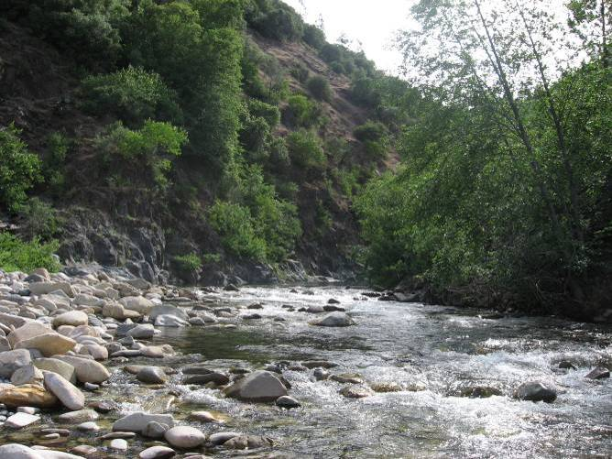 | 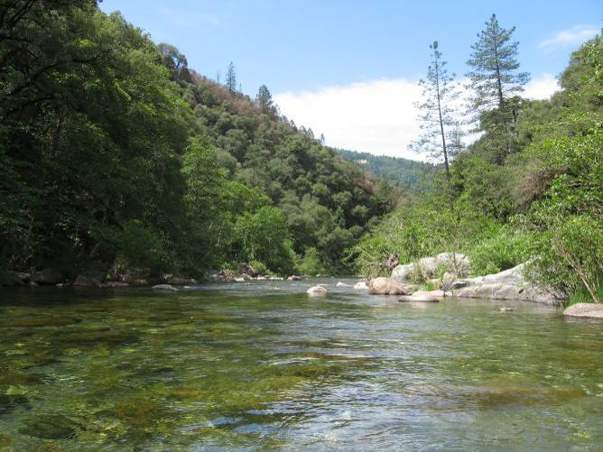
Representative run habitat, looking upstream. |  | Representative pool habitat, looking downstream.

AMPH NF 31.5 North Fork American River
The North Fork American River was a perennial stream that flowed within moderately steep canyon walls. The valley bottom was mostly narrow with no floodplains. Instream habitats included riffle-pool sequences with associated cobble bars in wider channel sections and higher-gradient habitats with bedrock and boulder substrates where the valley narrowed. Riparian vegetation was patchy and dominated by small willow and alder shrubs and trees, and canopy cover was generally low Suitable breeding locations were sparse, located along the margins of cobble bars. Infrequent breeding habitat locations included shallow to moderately deep, slow velocity areas protected by boulders.

AMPH NF 31.5 NORTH FORK AMERICAN RIVER
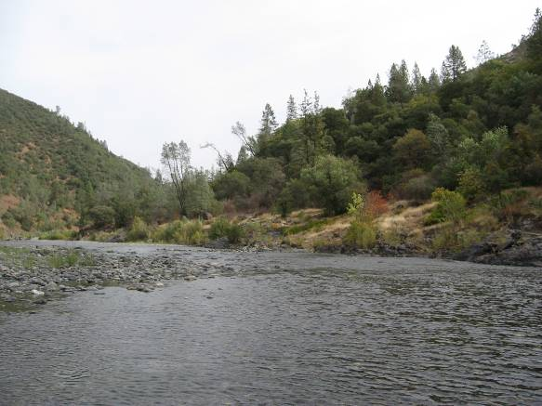 | 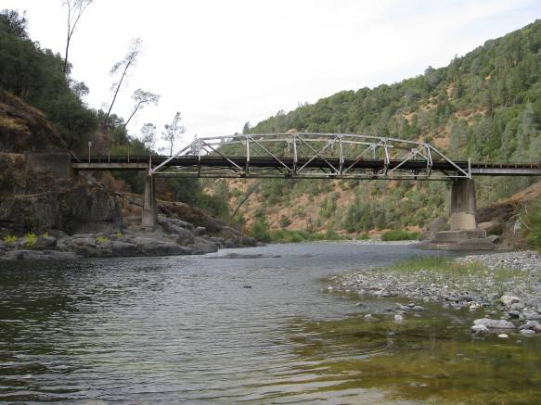
Representative habitat for North Fork American River.

AMPH NF 35.7 North Fork American River at Shirttail Creek and Bunch Canyon
At Shirttail Creek and Bunch Canyon, the North Fork American River channel flowed within steep canyon walls, and the valley bottom widened at the tributary confluences. Instream habitats included high-gradient riffles, runs, and pools with coarse boulder and cobble substrates. Riparian vegetation distribution was patchy and dominated by small willow and alder shrubs and trees. Canopy coverage along the stream margin was generally less than 25%. Suitable breeding locations occurred in boulder-protected margins of runs and along the margin of side channel bars.

During the breeding season (May 10 through June 5), flows ranged from approximately 50 cfs to 500 cfs. A peak flow of 7,240 cfs was recorded during the early spring, prior to the breeding season (Gage No. 11427000). Average daily water temperatures just upstream of the Shirttail Creek confluence (RM 38.0) during this time ranged from 53 ºF to 70 ºF, with an average of 61 ºF. During the month of August, flows were approximately 40 cfs and average daily water temperatures ranged from 64 ºF to 76 ºF, with an average of 70 ºF. Observed non-native predators included brown trout, smallmouth bass and crayfish.

AMPH NF 35.7 NORTH FORK AMERICAN RIVER AT SHIRTTAIL CREEK AND BUNCH CANYON
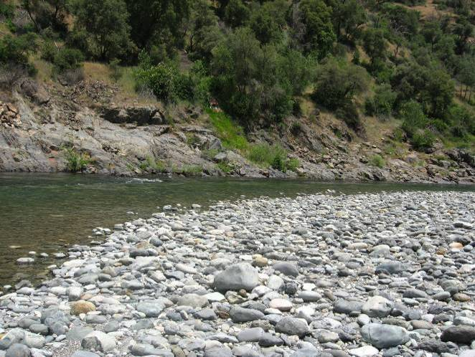 | 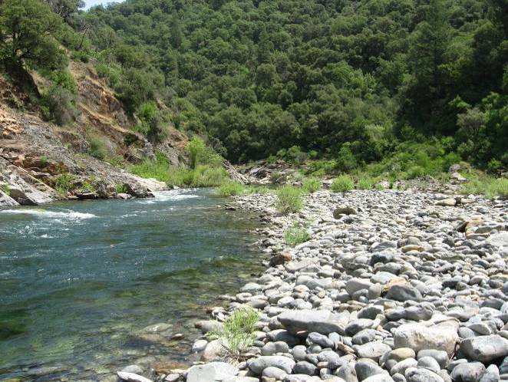
Representative habitat for North Fork American River, looking upstream. Potential breeding habitat occurred along margin of cobble bar (photo taken in fall). |  | Breeding habitat occurred along cobble bar margin, looking upstream.

AMPH NF 35.7 Shirttail Creek
Shirttail Creek was a perennial stream, approximately 6 meters wide near the confluence, typically with a small floodplain along at least one bank. Upstream, the channel narrowed and floodplains became less frequent. Instream habitats were predominately step-pools, riffles and runs, transitioning to cascades and plunge-pools as gradient increased upstream. Substrates were dominated by bedrock and boulder with cobble occurring in depositional areas. Riparian vegetation was patchy and dominated by small to medium-sized willow and alder trees and shrubs. Canopy cover along the stream margin was typically less than 50%. Quality breeding habitat locations occurred primarily in pool tailouts near the confluence, shallow boulder-protected areas along pool and run margins upstream.

During the breeding season surveys, flows were approximately 7 cfs, and in August, flows were less than 3 cfs. Non-native aquatic predators were not observed during the field surveys.

AMPH NF 35.7 SHIRTTAIL CREEK
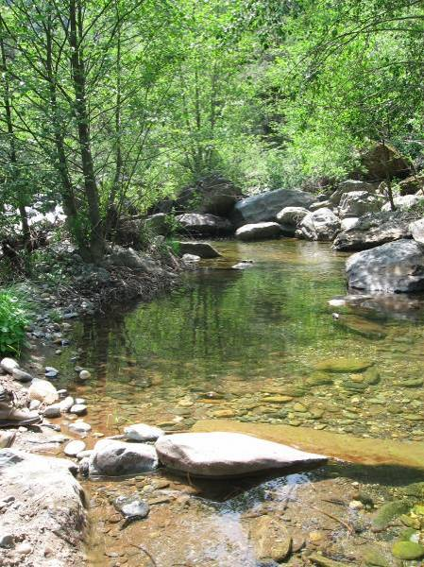 | 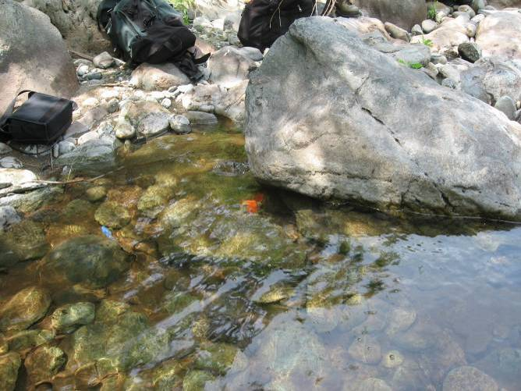
Representative habitat for Shirttail Creek, looking upstream. |  | Breeding habitat in pool tailout along deposition bar margin, looking upstream. Red flagging marks eggmass location (shown with white arrow).

AMPH NF 35.7 Bunch Canyon
Bunch Canyon was a small perennial stream (less than 10 meters wide) confined within steep canyon walls. The canyon was a tributary of the North Fork American River, located approximately 500 meters downstream of Shirttail Creek. In the lower portion of the reach, small pools with cobble substrate and bedrock cascades were common. Upstream, the gradient and the size of cascades and pools increased. Canopy cover along the stream margin was typically less than 50%, with up to 100% cover in some areas. Willow and alder trees and shrubs were the primary shade providers. Suitable breeding habitat occurred in pool tailouts and the edges of runs.

During the field surveys, flows were less than 5 cfs, and crayfish were observed.

AMPH NF 35.7 BUNCH CANYON CREEK
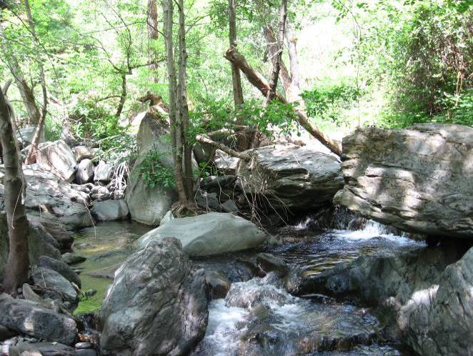 | 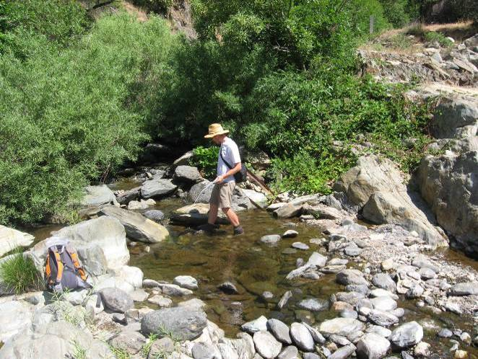
Representative habitat for Bunch Canyon, looking upstream (photo taken during fall survey). | Potential breeding habitat at downstream end of reach near confluence with AMPH NFAR 35.7 site.

AMPH NF 53.7 North Fork American River
The North Fork American River at AMPH NF 53.7 is similar to that described above at AMPH NF 35.7. The river is confined within moderately steep valley walls and instream habitats are predominantly moderate-gradient riffles, runs and pools. Bedrock and boulder are the dominant substrates in higher-gradient sections, while boulder and cobble bars occur where the channel widens. Riparian vegetation was patchy, occurring on a few bars or in protected areas along the channel. Canopy cover was generally low. The vegetation was comprised of small willow and alder shrubs and trees. Suitable breeding locations occurred in boulder-protected margins of runs and along the margin of side channel bars.

AMPH NF 53.7 NORTH FORK AMERICAN RIVER
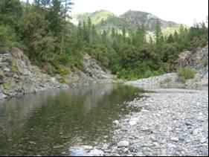 | 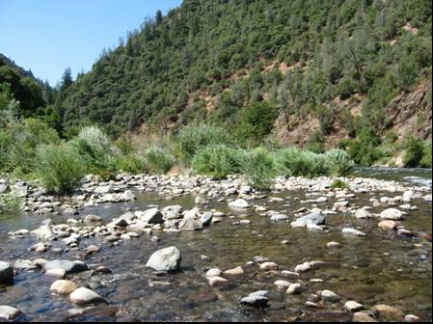
Representative habitat for the North Fork American River.

North Fork of the Middle Fork American River
One site was surveyed along the North Fork of the Middle Fork American River, which is characterized in the following section.

AMPH NFMF 2.3 NORTH FORK OF THE MIDDLE FORK AMERICAN RIVER
The North Fork of the Middle Fork American River was a moderately-sized perennial river (approximately 11 meters wide) confined within steep canyon walls. The overall gradient of the stream was moderate with step/pool sequences and runs as the dominant habitat types. A well-developed boulder/cobble armor overlaying a bedrock channel floor was characteristic of the reach, though a few bedrock knick points were observed. Small floodplains were present on at least one side of the reach for the majority of its length. Riparian vegetation was patchy and dominated by willow and alder shrubs and trees. Canopy cover was generally less than 25%. Suitable breeding habitat was available throughout the reach and was present primarily in boulder-protected edges of runs. One large backwater in a side channel provided particularly good breeding habitat and contained abundant FYLF, Pacific Treefrog and Western Toad tadpoles during the fall survey.

During the breeding season (May 10 through June 5), flows ranged between approximately 50 cfs and 100 cfs (Gage No. P-F1). Average daily water temperatures within the North Fork of the Middle Fork American River at RM 2.3 ranged from 53 ºF to 70 ºF during this time period, with an average of 61 ºF. During the month of August, flows were approximately 20 cfs. Average daily water temperatures ranged from 64 ºF to 76 ºF, with an average of 70 ºF. Crayfish were observed during site visits.

AMPH NFMF 2.3 NORTH FORK MIDDLE FORK AMERICAN RIVER
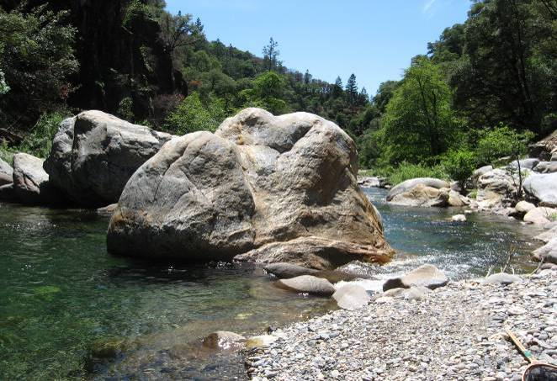 | 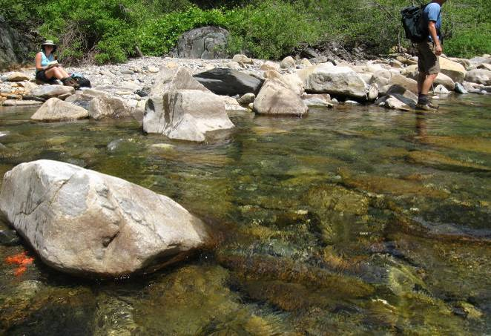
Representative habitat for the North Fork of the Middle Fork American River, looking downstream. Potential breeding habitat occurred along edgewater of run. | Breeding habitat along cobble bar margin, looking downstream. Red flagging to the right of large boulder marks eggmass location (shown with white arrow).

AMPH NFMF 2.3 NORTH FORK OF THE MIDDLE FORK AMERICAN RIVER DOWNSTREAM OF CIRCLE BRIDGE
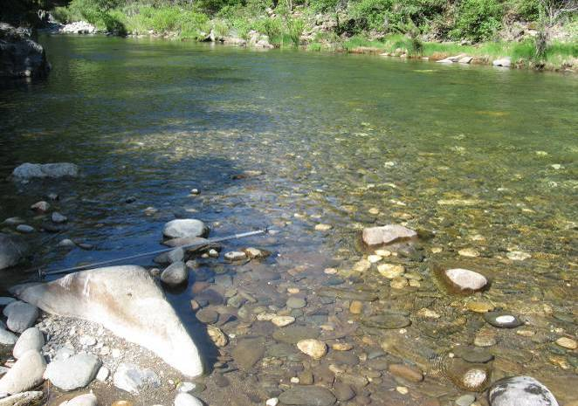 | 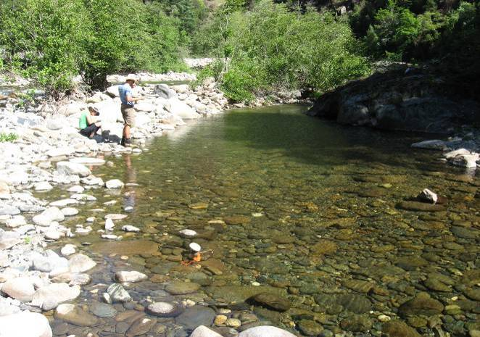
Representative habitat for North Fork of the Middle Fork American River, looking upstream. Breeding habitat occurred at upstream end of bar at bottom of photo | Breeding habitat in side channel backwater, looking upstream. Red flagging marks eggmass location (shown with white arrow).

References

PCWA. 2007. Middle Fork American River Project (FERC 2079) 2006 Draft Physical Habitat Characterization Study. April, 2007.

